ASSIGNMENT

**NAME: RAMAVATH SANTHOSH**

**ROLL NO: 22MCF1R40**

**2ND SEMESTER, 1ST YEAR, MCA**

OUTPUTS:

1)

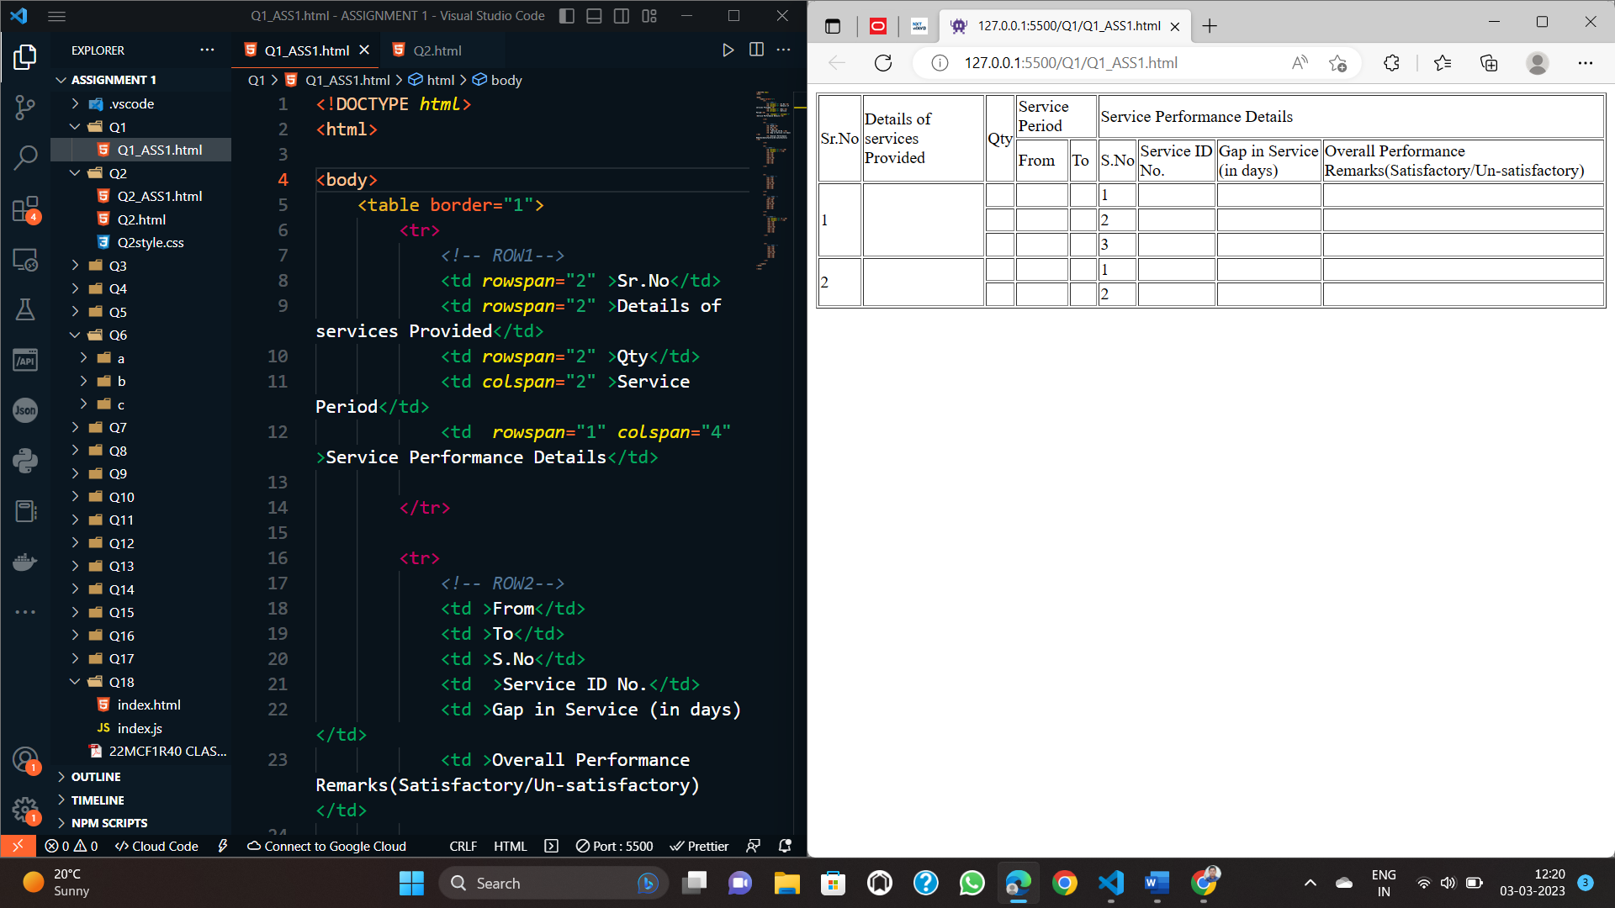

2)

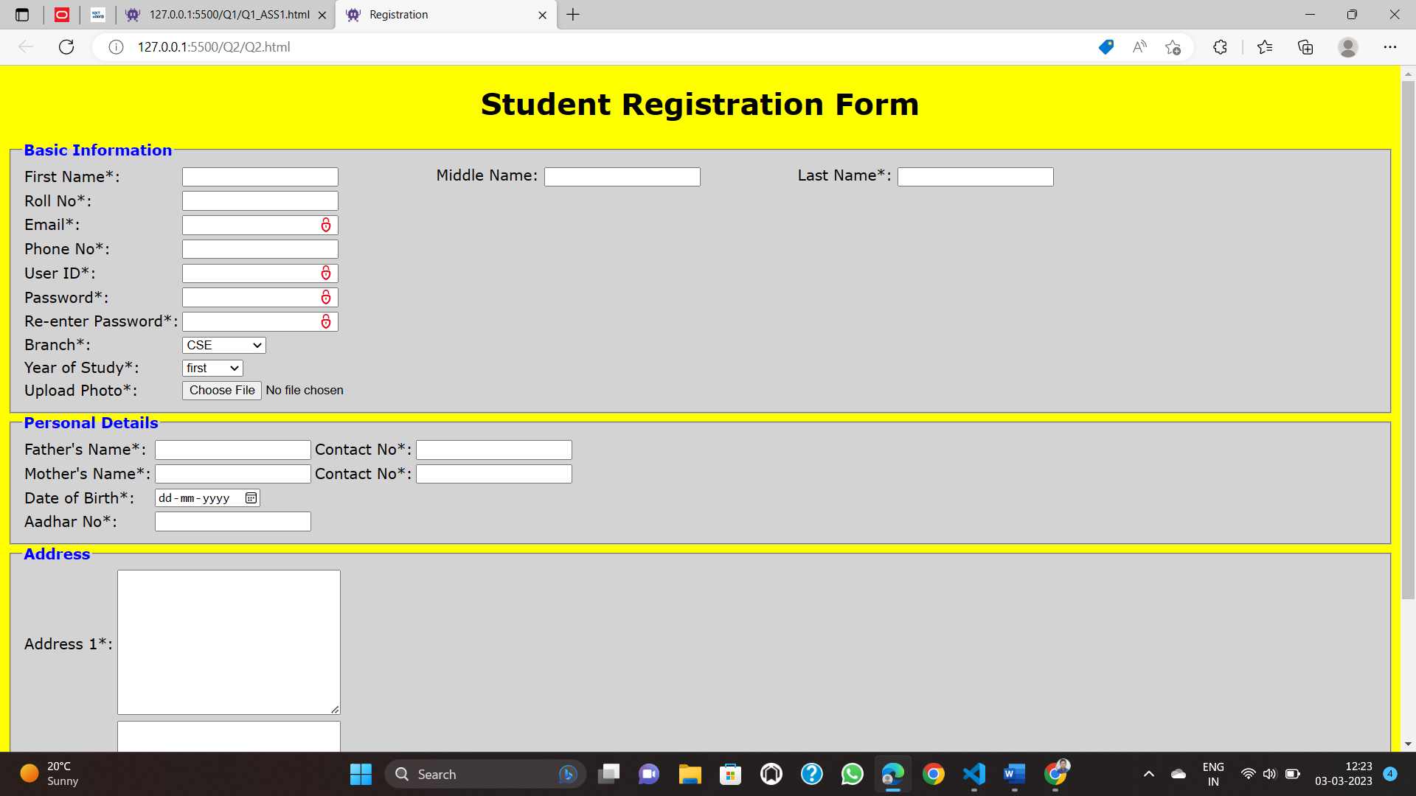

3)



4)

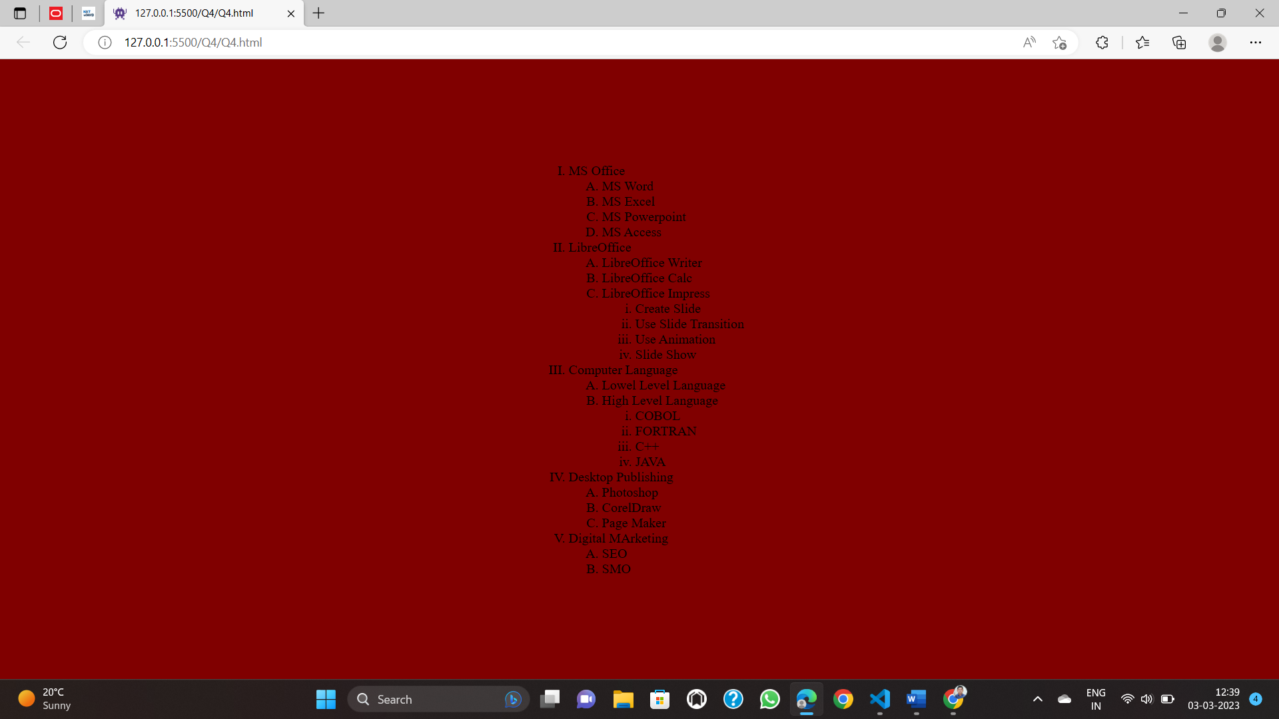

5)

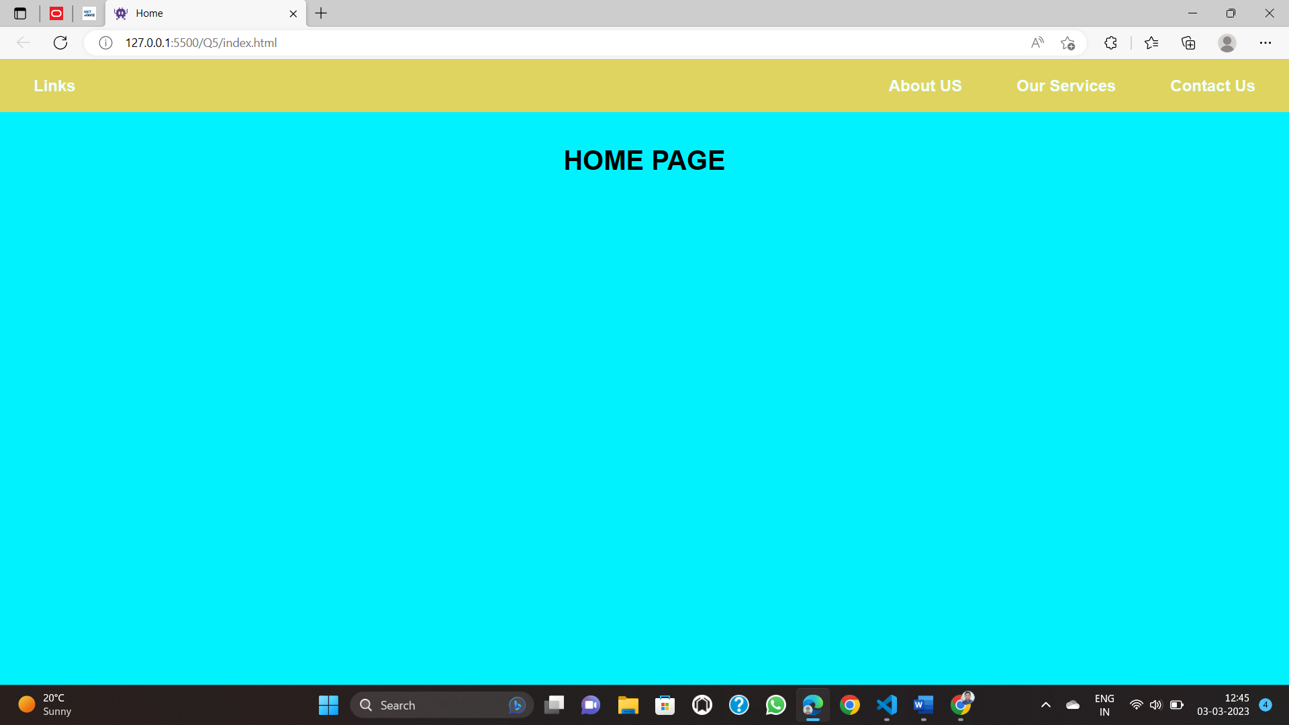

6) a)

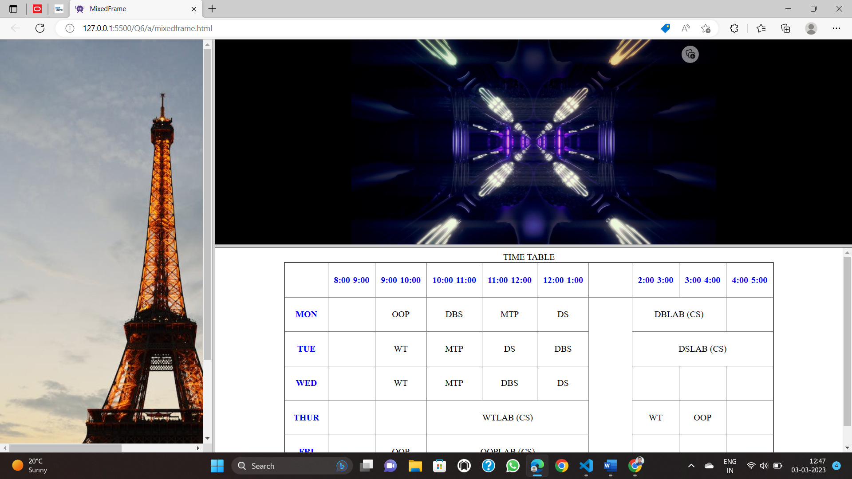

6) b)

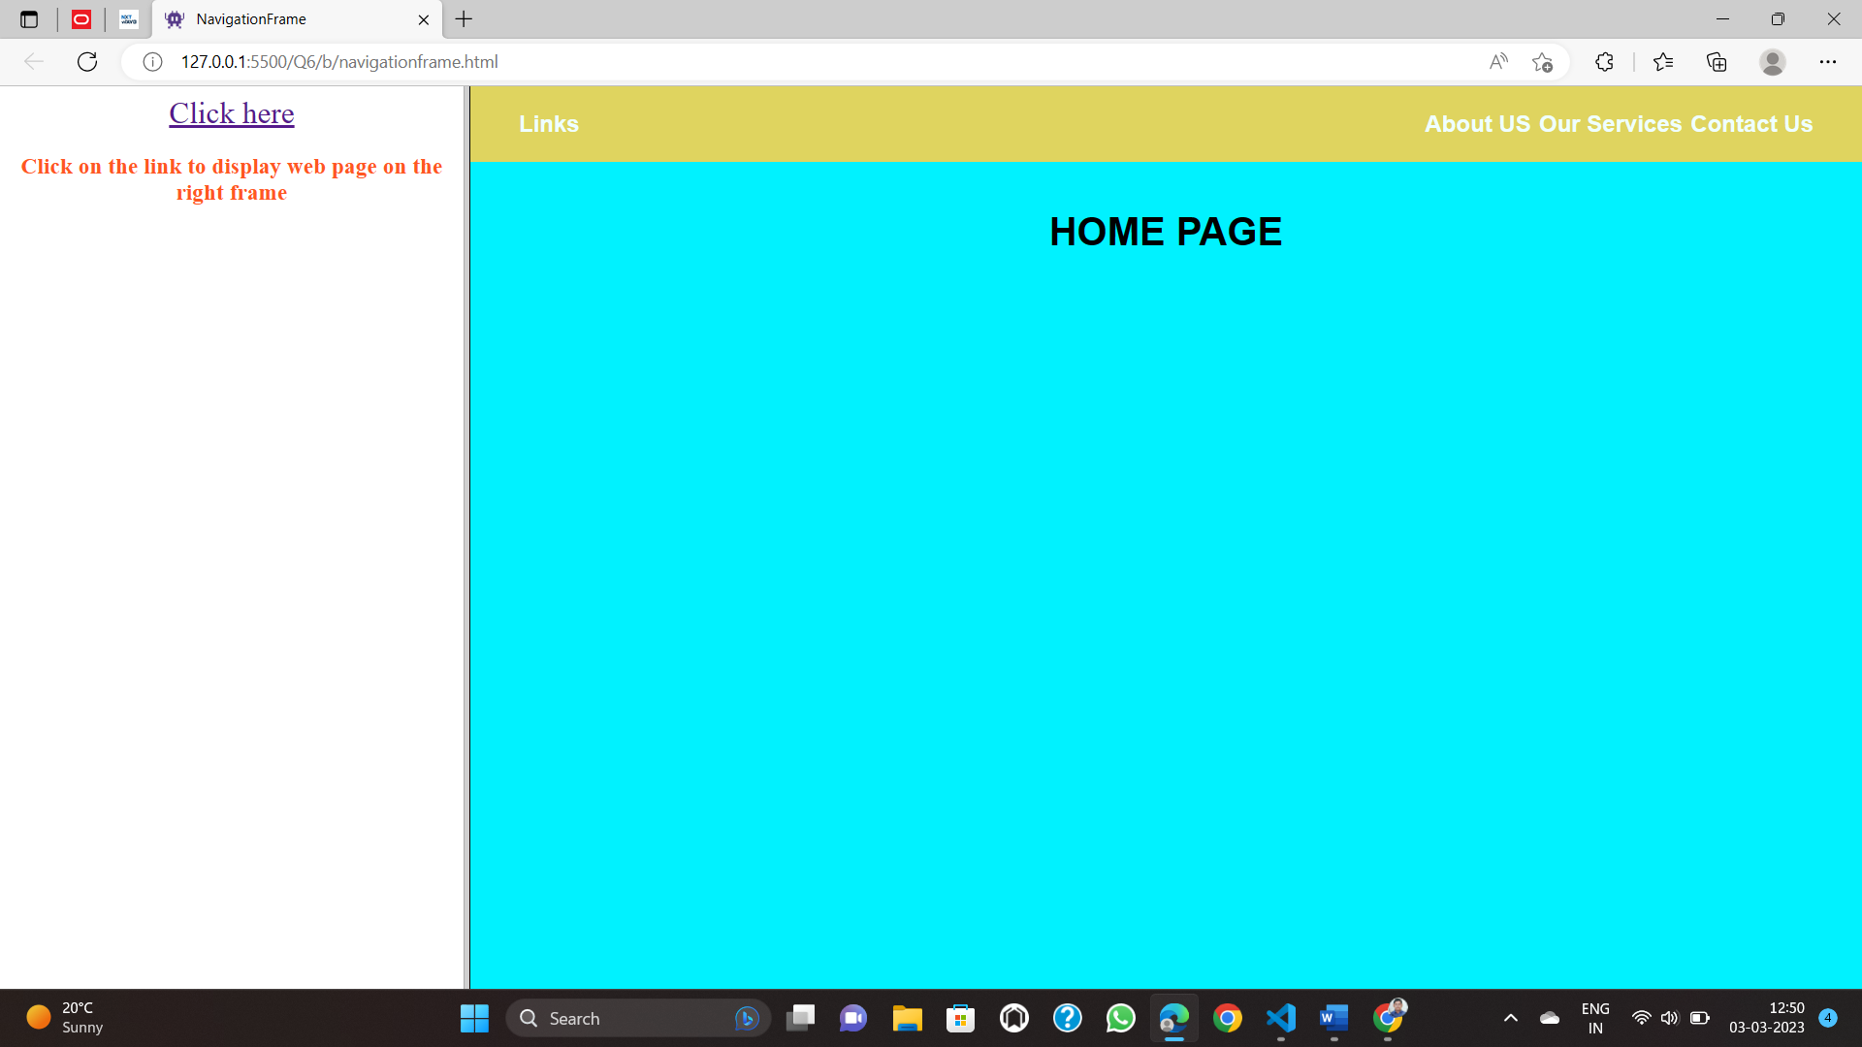

6) c)

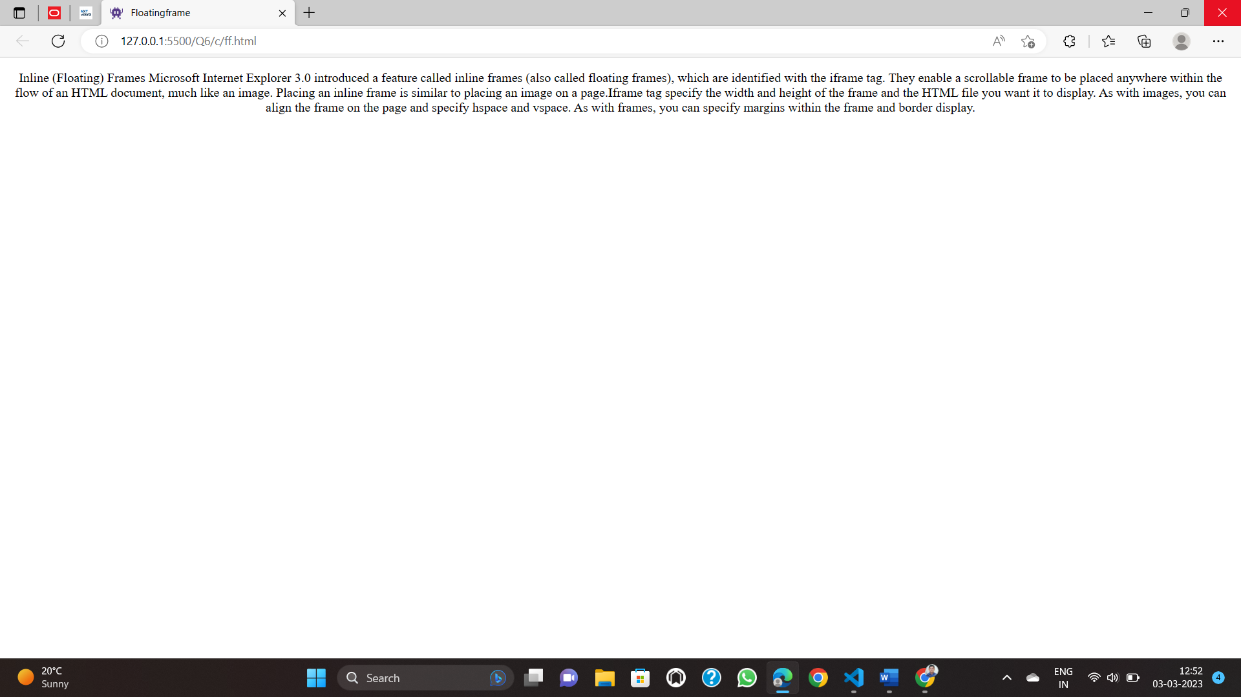

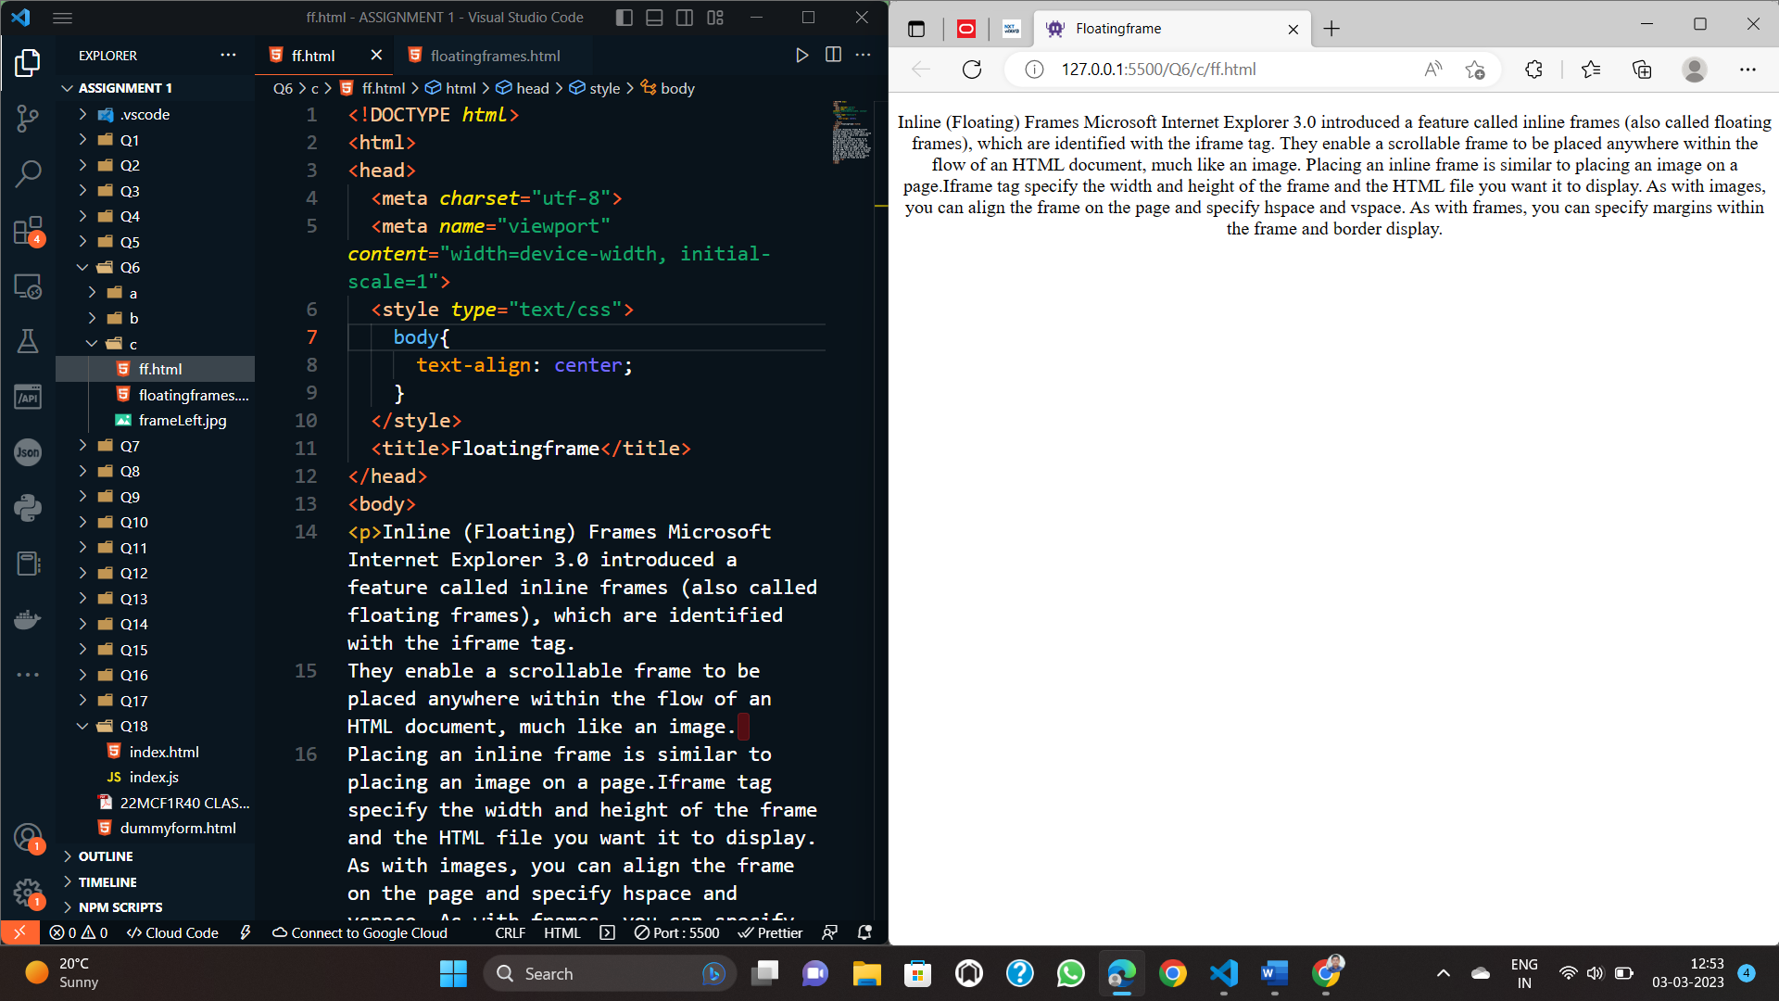

7) 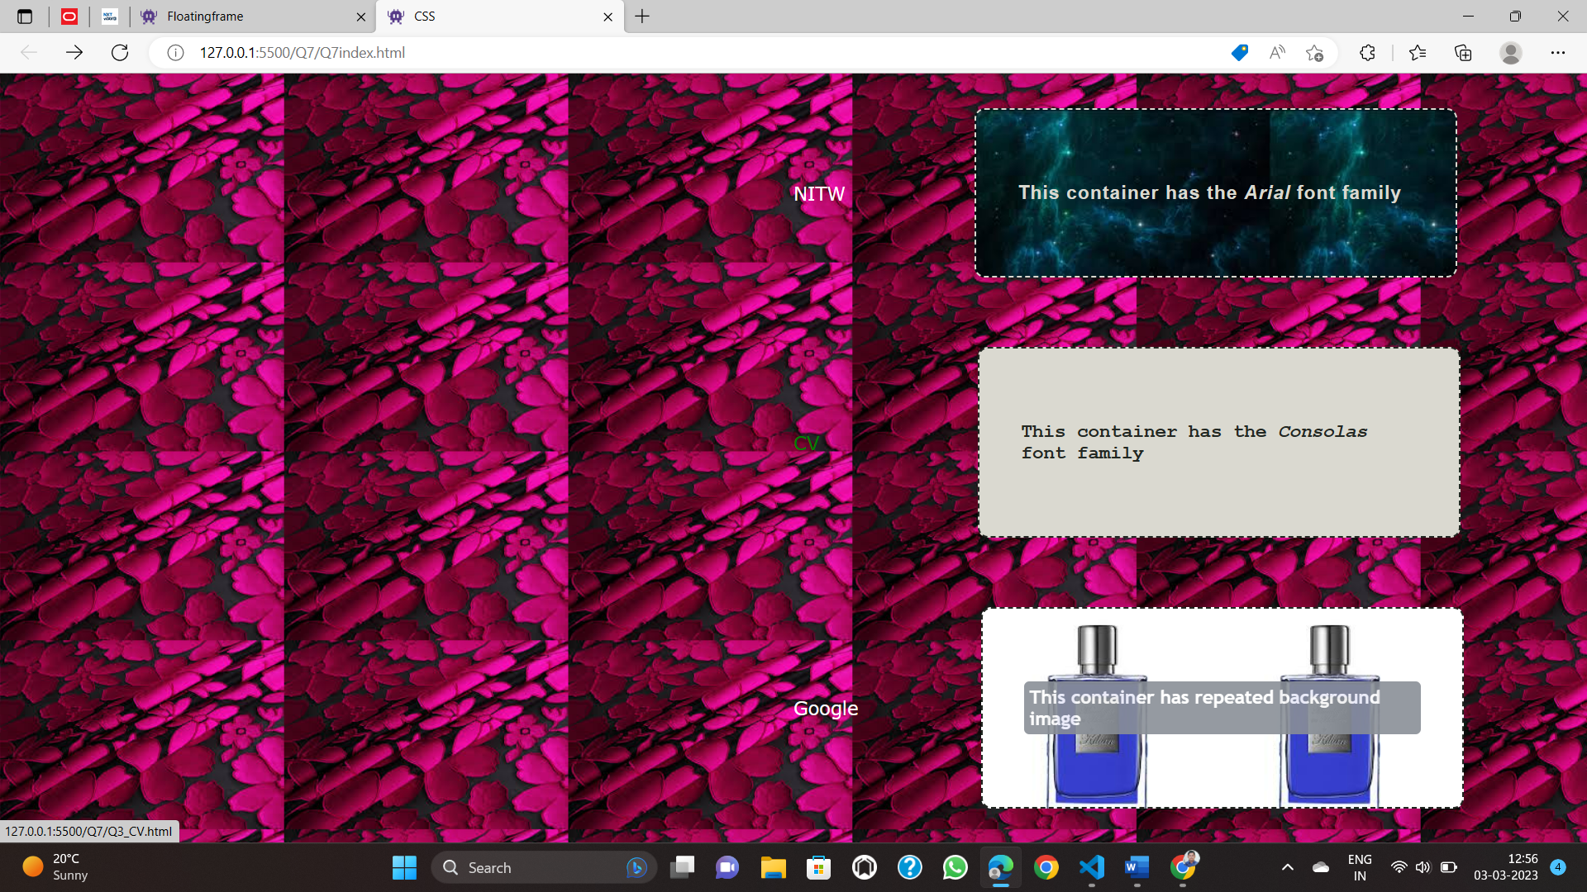

8)

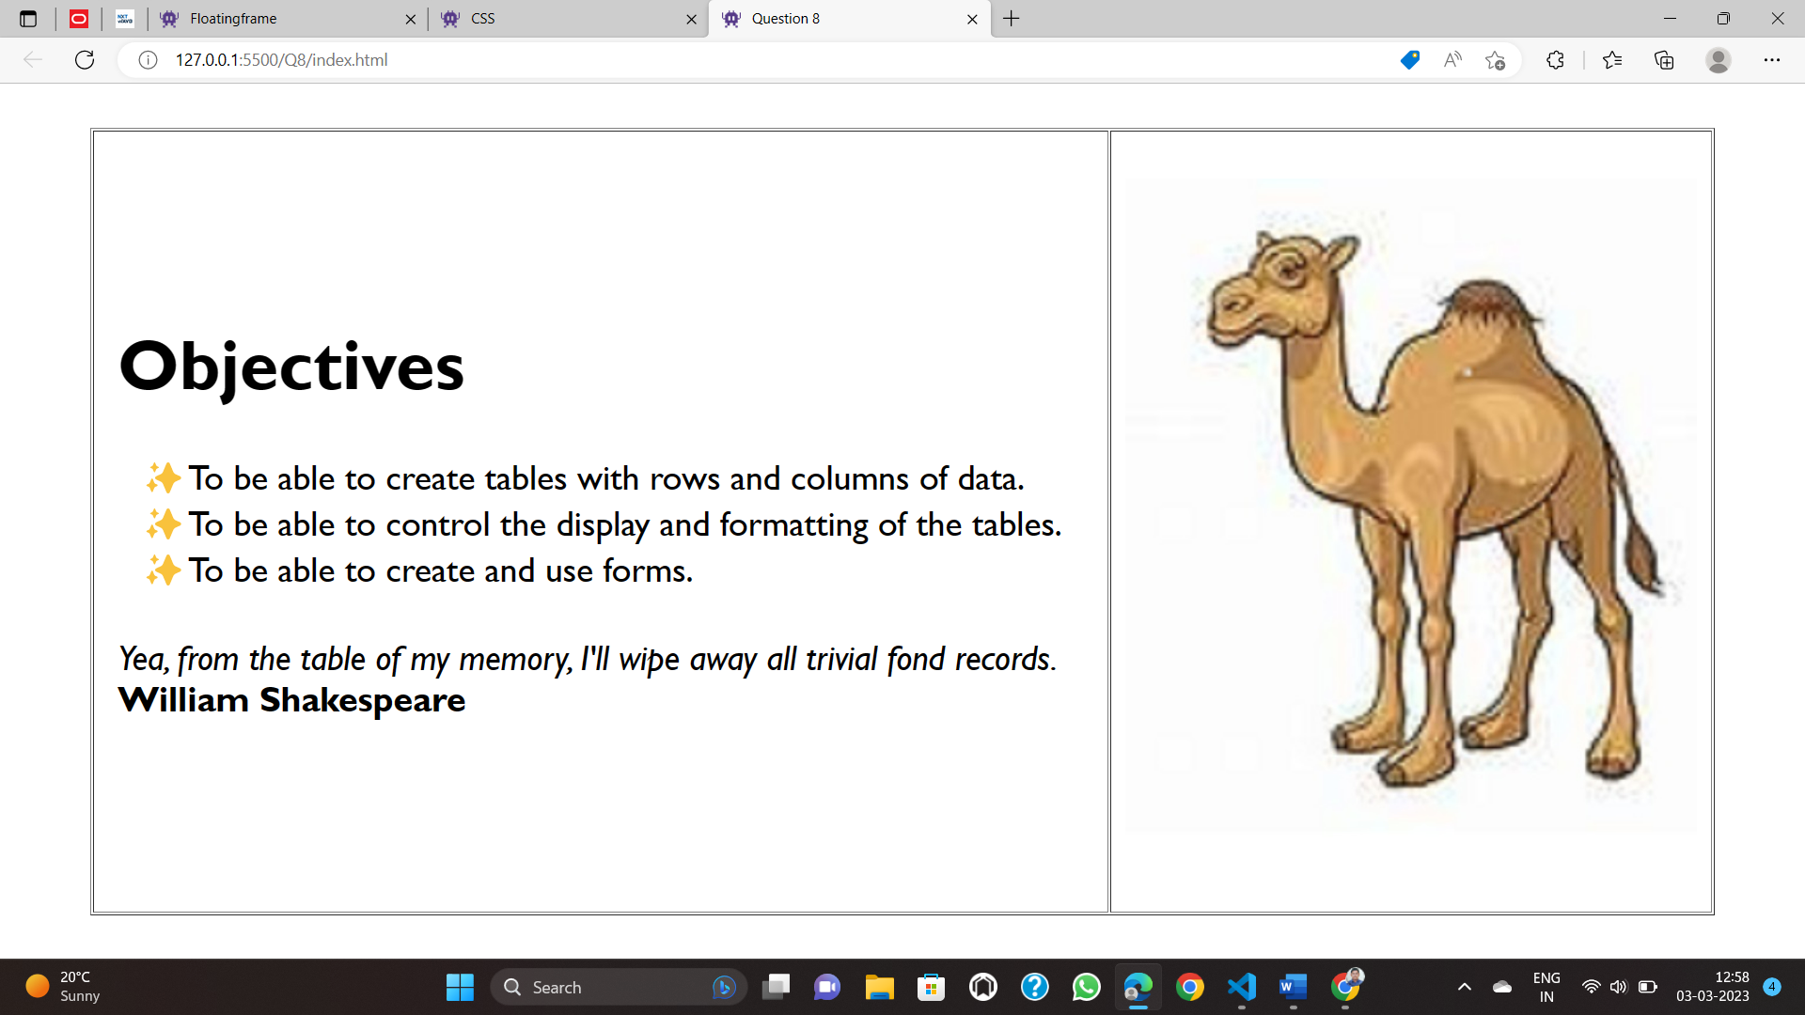

9) i)

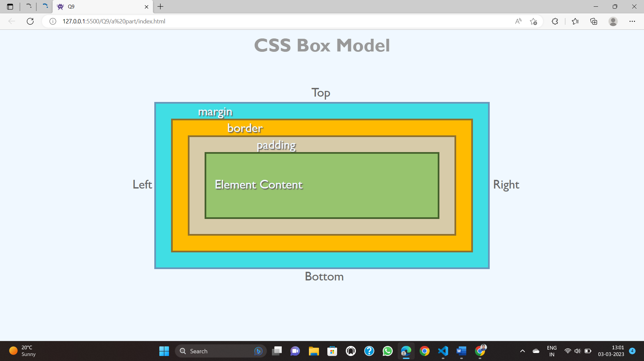

9) ii)

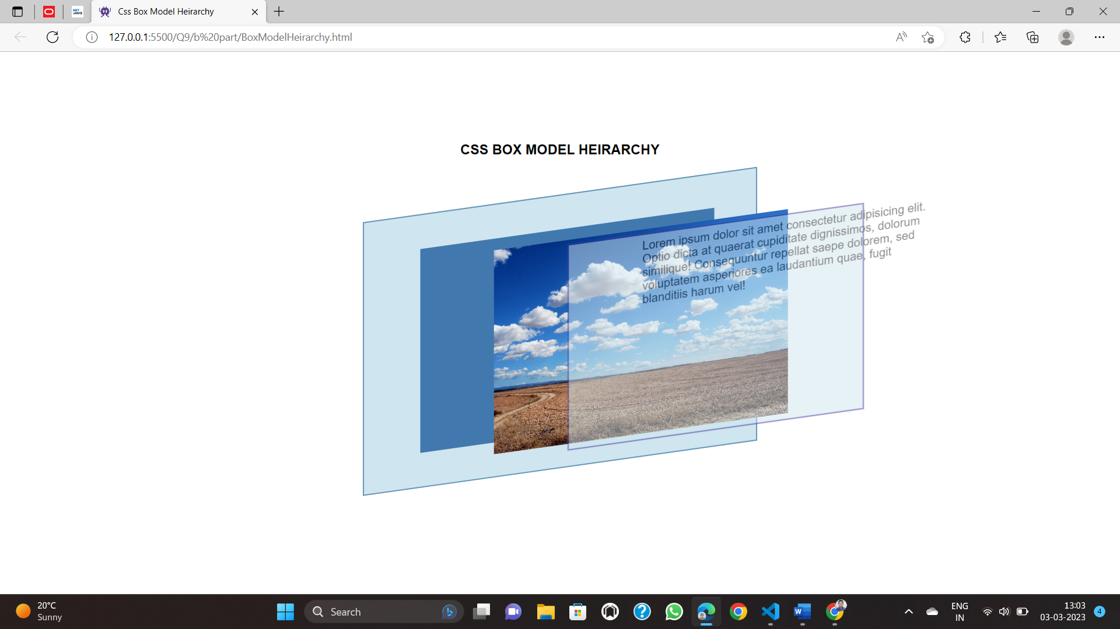

10)

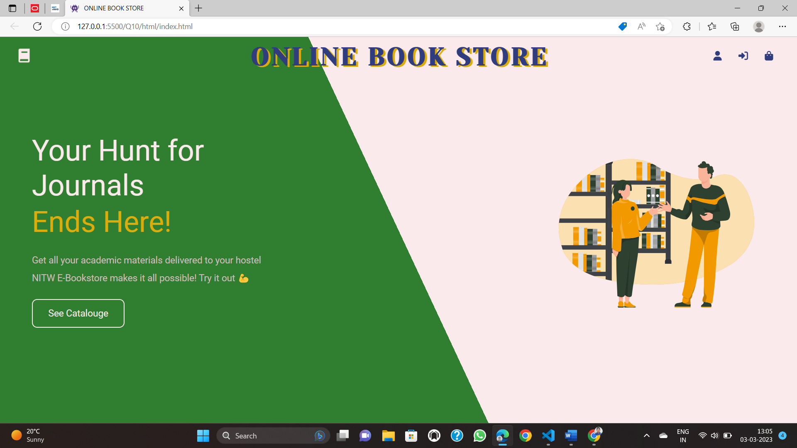

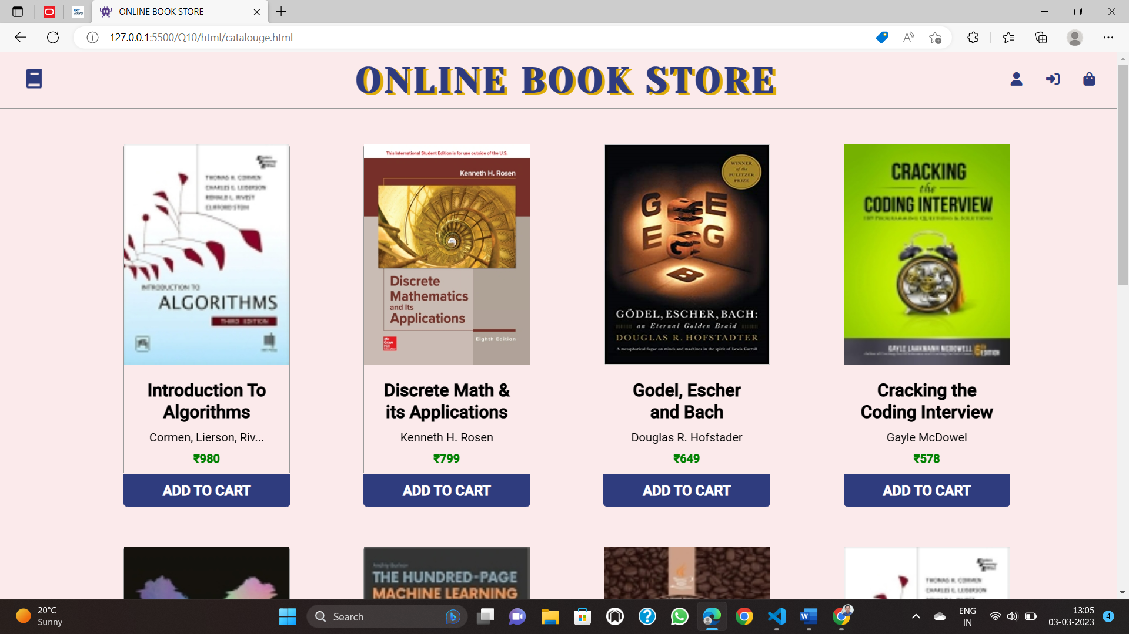

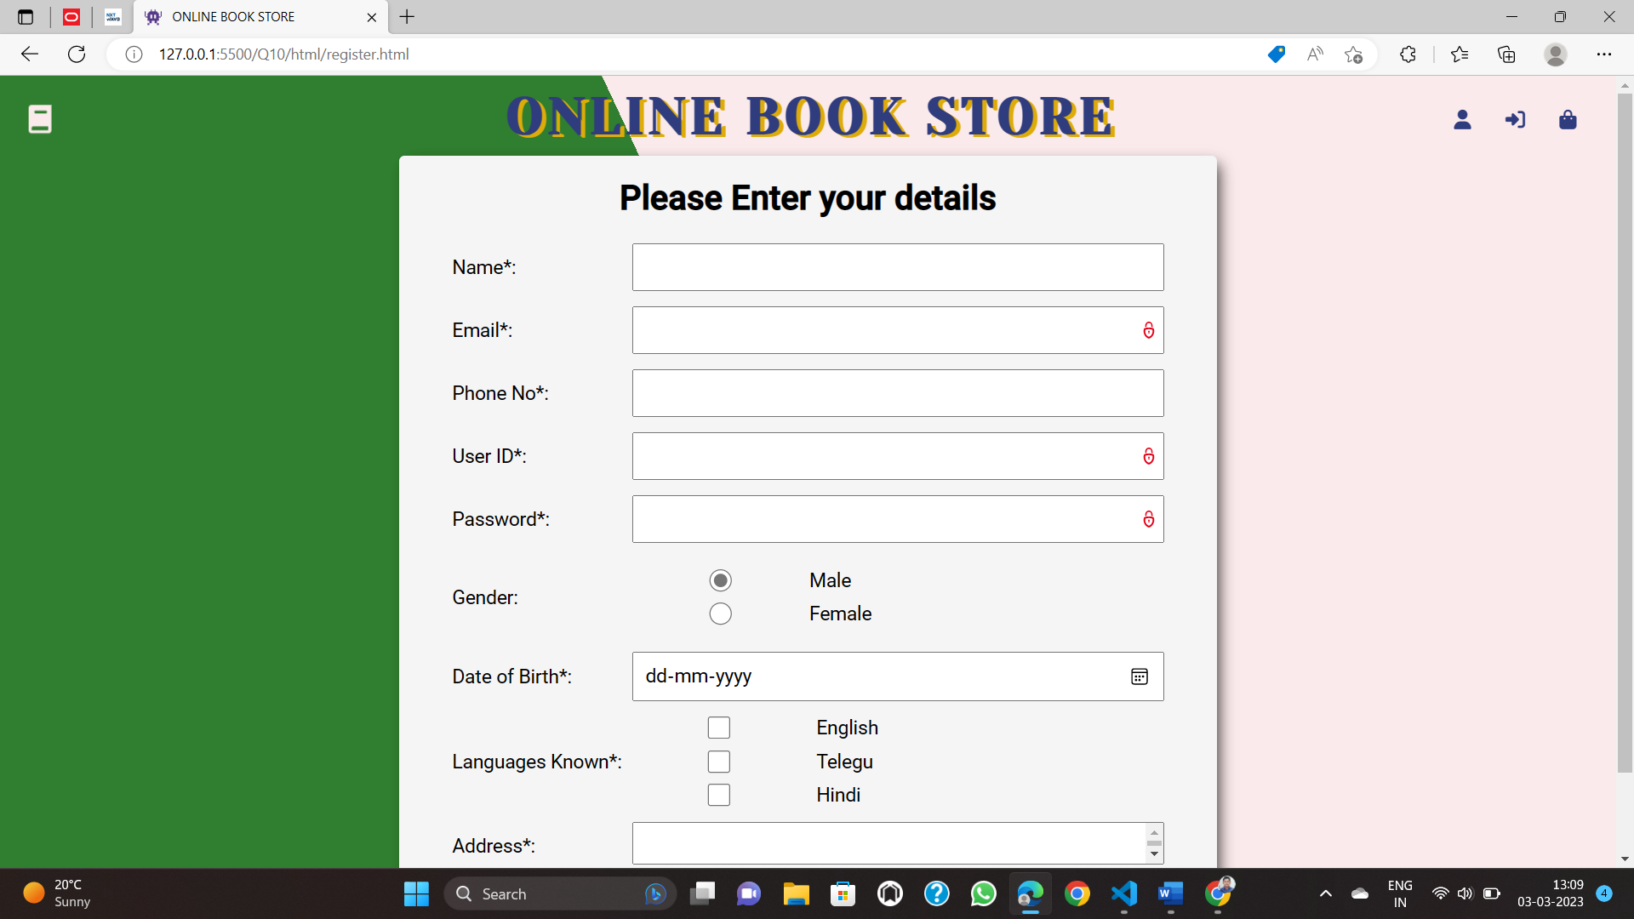

12)

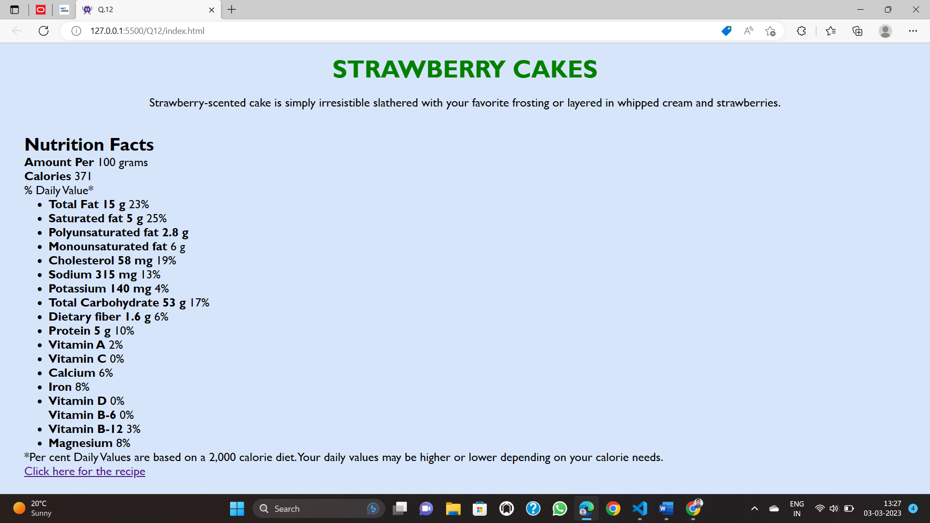

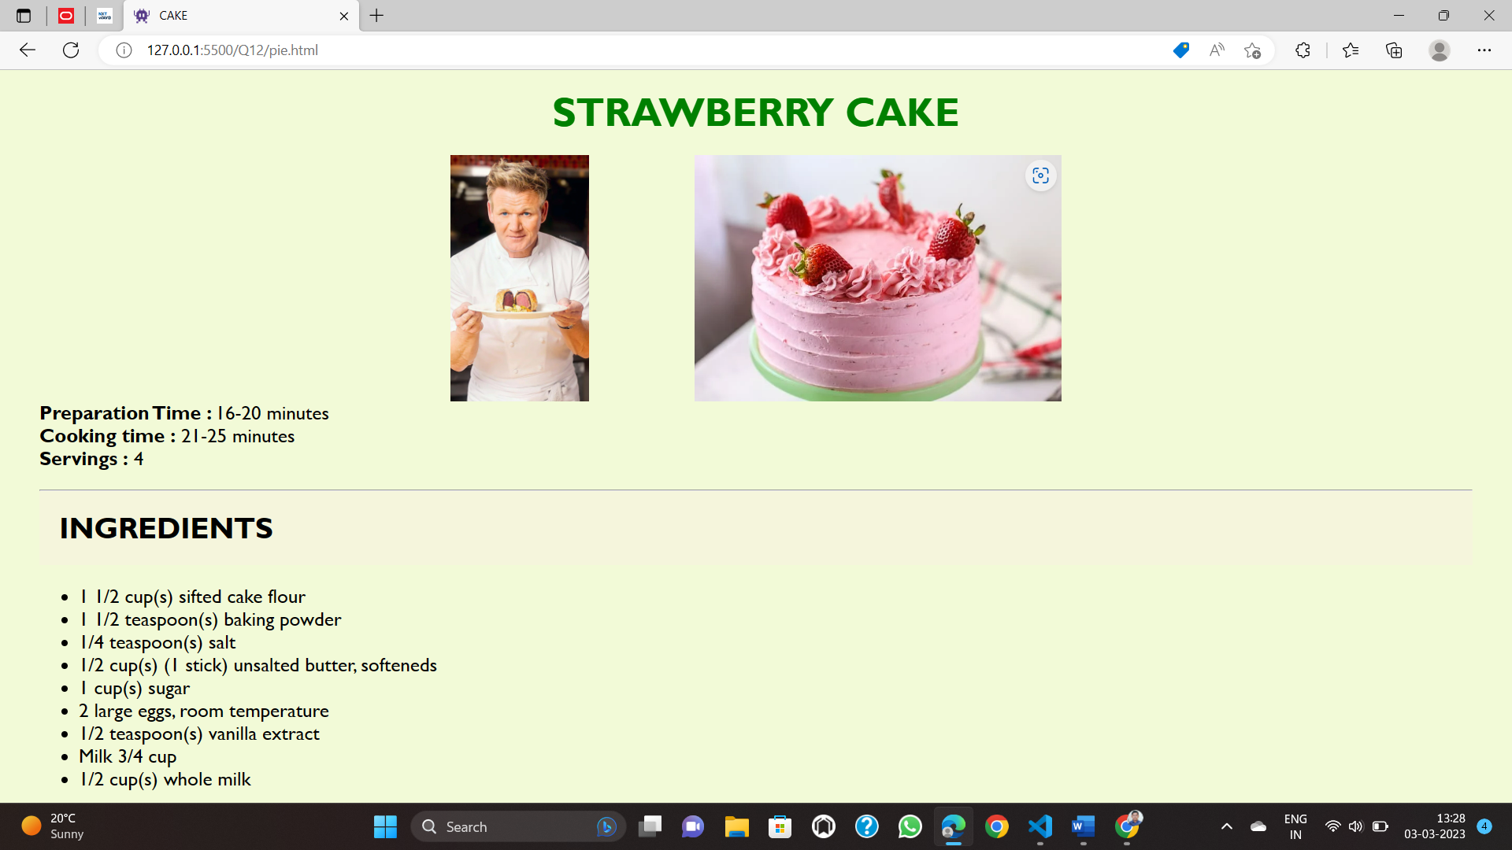

13)

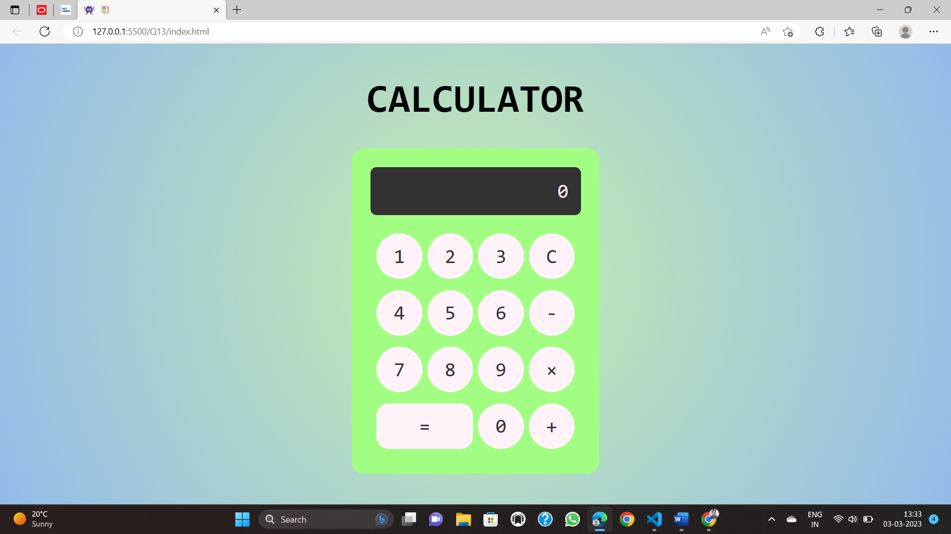

14)

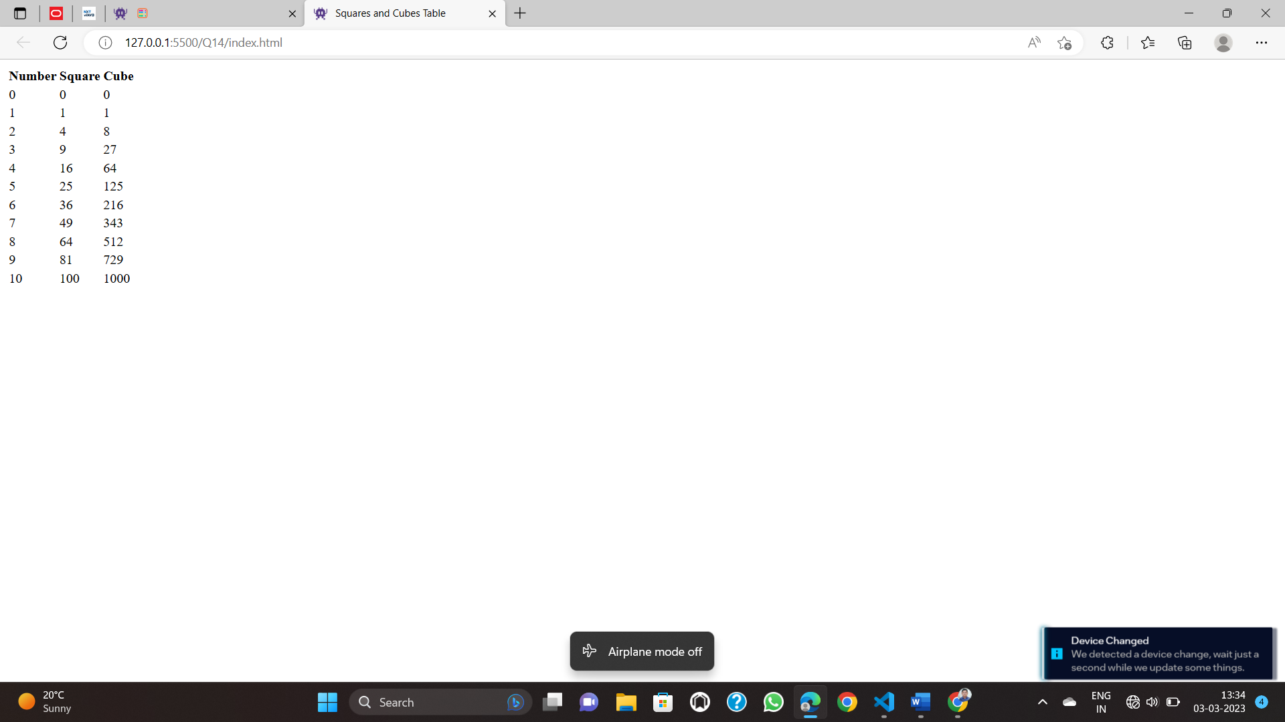

15)

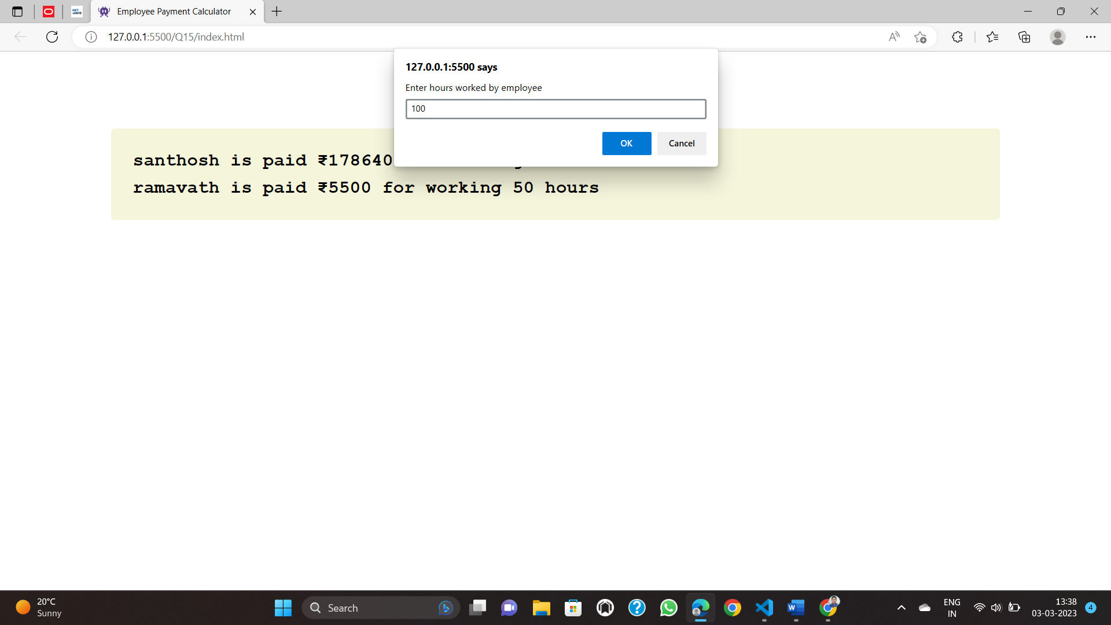

16)

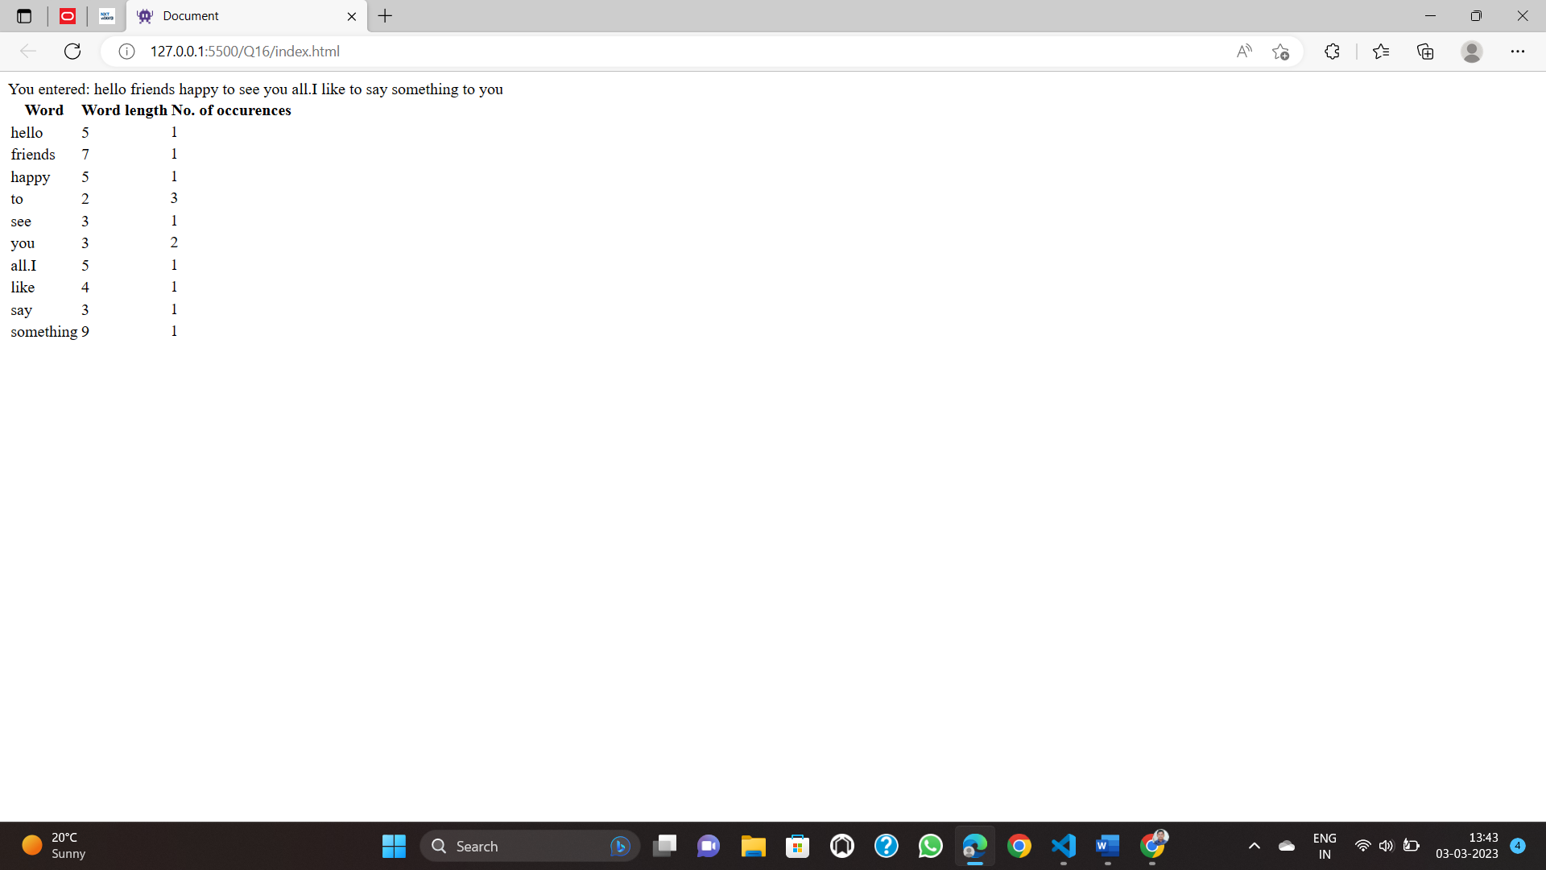

17)

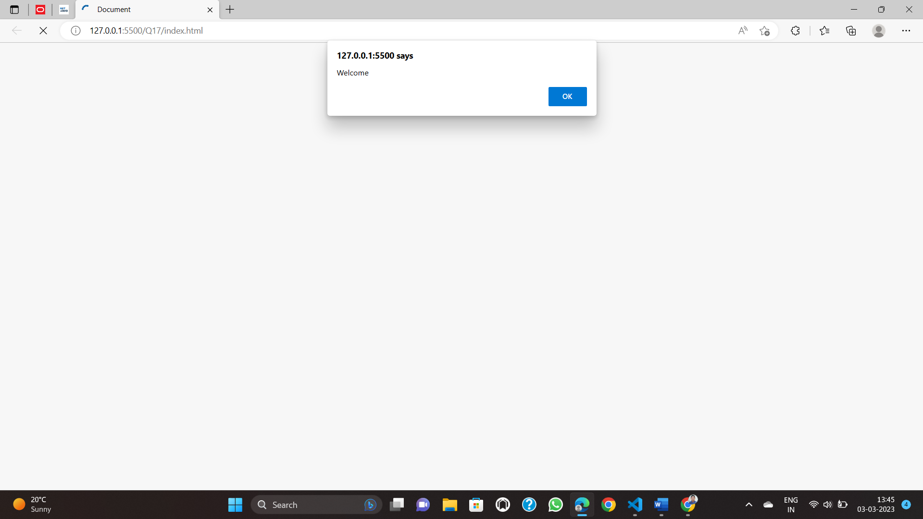 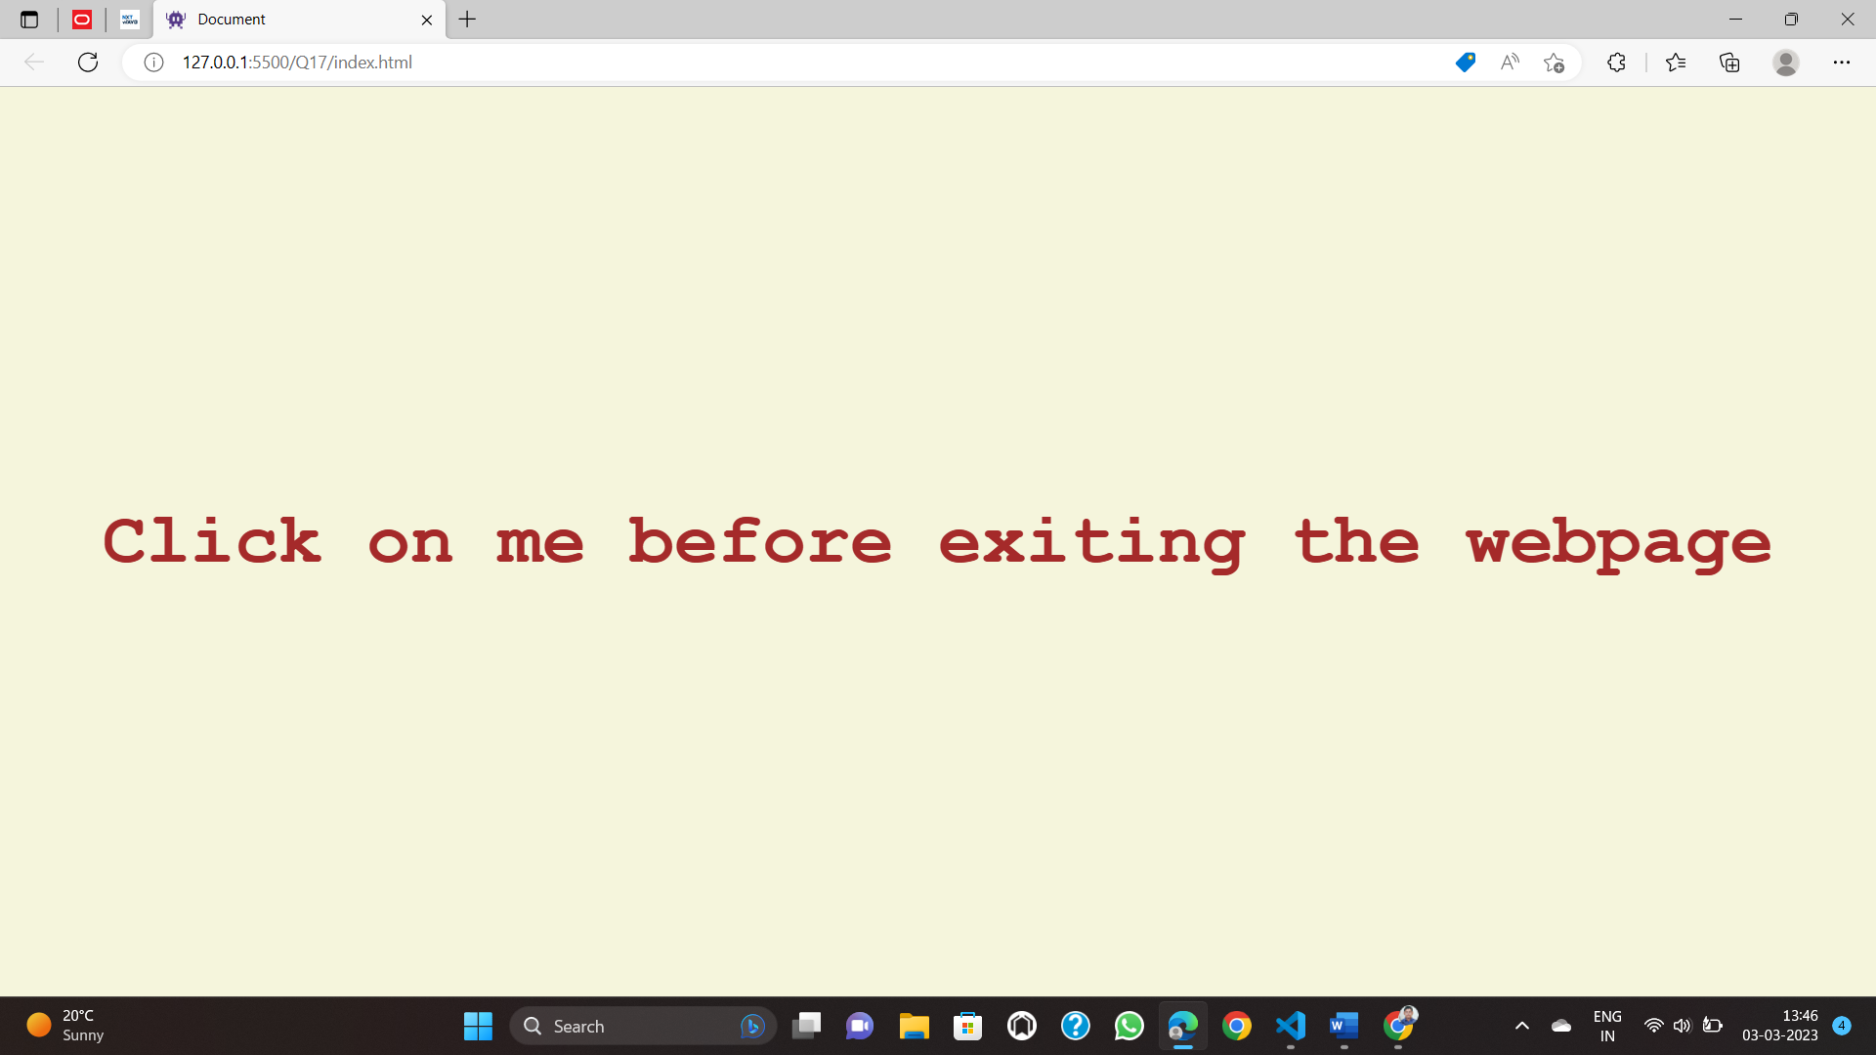

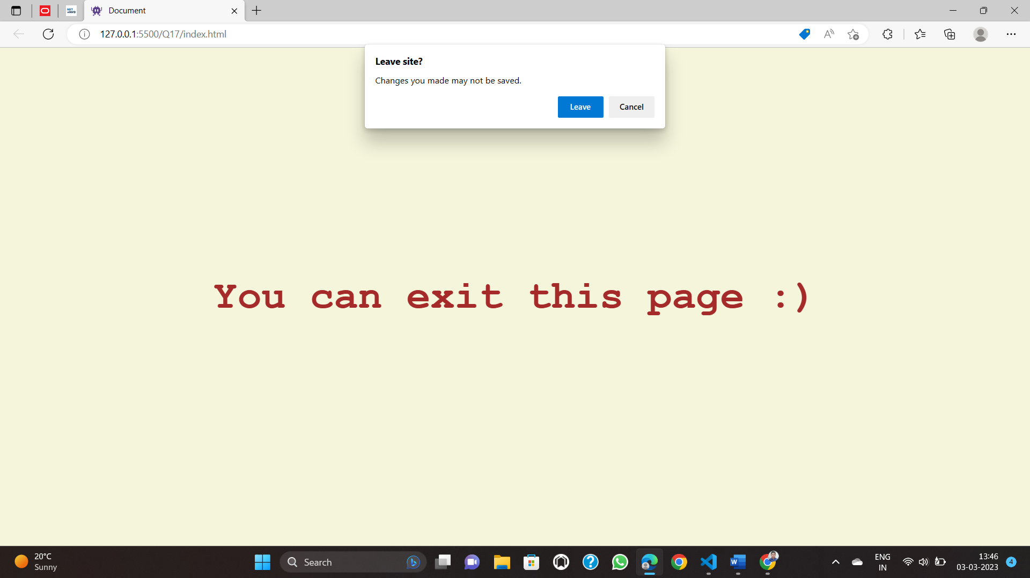

18)

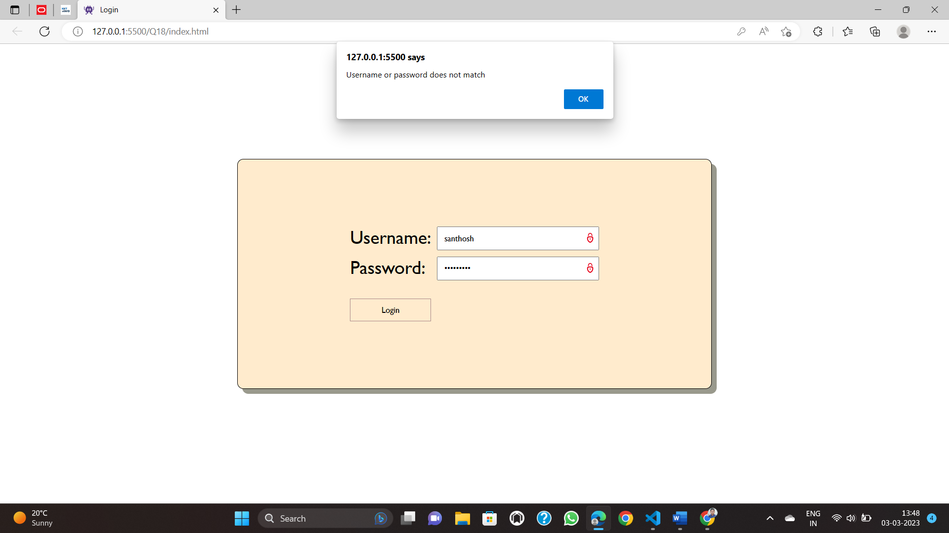

1.Design a webpage to display following table.

CODE:

<!DOCTYPE *html*>

<html>

<body>

    <table border="1">

        <tr>

*<!-- ROW1-->*

            <td *rowspan*="2" >Sr.No</td>

            <td *rowspan*="2" >Details of services Provided</td>

            <td *rowspan*="2" >Qty</td>

            <td *colspan*="2" >Service Period</td>

            <td  *rowspan*="1" *colspan*="4" >Service Performance Details</td>

        </tr>

        <tr>

*<!-- ROW2-->*

            <td >From</td>

            <td >To</td>

            <td >S.No</td>

            <td  >Service ID No.</td>

            <td >Gap in Service (in days)</td>

            <td >Overall Performance Remarks(Satisfactory/Un-satisfactory) </td>

        </tr>

        <tr>

*<!--ROW3-->*

            <td *rowspan*="3"> 1 </td>

            <td *rowspan*="3"> </td>

            <td></td>

            <td></td>

            <td></td>

            <td>1</td>

            <td></td>

            <td></td>

            <td></td>

        </tr>

        <tr>

*<!-- ROW4 -->*

            <td></td>

            <td></td>

            <td></td>

            <td>2</td>

            <td></td>

            <td></td>

            <td></td>

        </tr>

        <tr>

*<!-- ROW5 -->*

             <td></td>

            <td></td>

            <td></td>

            <td>3</td>

            <td></td>

            <td></td>

            <td></td>

        </tr>

        <tr>

*<!--ROW6-->*

             <td *rowspan*="3"> 2 </td>

             <td *rowspan*="3"> </td>

             <td></td>

             <td></td>

             <td></td>

             <td>1</td>

             <td></td>

             <td></td>

             <td></td>

         </tr>

         <tr>

*<!-- ROW7 -->*

             <td></td>

             <td></td>

             <td></td>

             <td>2</td>

             <td></td>

             <td></td>

             <td></td>

         </tr>

    </table>

</body>

</html>



2. Create an html page named as “registration.html”

a) Set background colors as blue

b) Use table for alignment

c) Provide font colors & size.

CODE:

<!DOCTYPE *html*>

<html *lang*="en">

<head>

    <meta *charset*="UTF-8">

    <meta *http-equiv*="X-UA-Compatible" *content*="IE=edge">

    <meta *name*="viewport" *content*="width=device-width, initial-scale=1.0">

    <title>Registration</title>

    <link *rel*="stylesheet" *href*="Q2style.css">

</head>

<body>

    <h1 align="center">Student Registration Form</h1>

    <form *action*="#">

        <fieldset>

            <legend>Basic Information</legend>

            <table>

                <tr>

                    <td>

                        <label *for*="fname">First Name*:</label>

                    </td>

                    <td>

                        <input *type*="text" *name*="fname" *id*="" *required*>

                        <span *class*="ml">

                            <label *for*="mname">Middle Name:</label>

                            <input *type*="text" *name*="mname" *id*="">

                        </span>

                        <span *class*="ml">

                            <label *for*="lname">Last Name*:</label>

                            <input *type*="text" *name*="lname" *id*="" *required*>

                        </span>

                    </td>

                </tr>

                <tr>

                    <td>

                        <label *for*="roll">Roll No*:</label>

                    </td>

                    <td><input *type*="text" *name*="roll" *id*="" *required*></td>

                </tr>

                <tr>

                    <td>

                        <label *for*="email">Email*:</label>

                    </td>

                    <td><input *type*="email" *name*="email" *id*="" *required*></td>

                </tr>

                <tr>

                    <td>

                        <label *for*="phone">Phone No*:</label>

                    </td>

                    <td><input *type*="number" *name*="phone" *id*="" *required*></td>

                </tr>

                <tr>

                    <td>

                        <label *for*="uid">User ID*:</label>

                    </td>

                    <td><input *type*="text" *name*="uid" *id*="" *required*></td>

                </tr>

                <tr>

                    <td>

                        <label *for*="pass">Password*:</label>

                    </td>

                    <td><input *type*="password" *name*="pass" *id*="" *required*></td>

                </tr>

                <tr>

                    <td>

                        <label *for*="rpass">Re-enter Password*:</label>

                    </td>

                    <td><input *type*="password" *name*="rpass" *id*="" *required*></td>

                </tr>

                <tr>

                    <td>

                        <label *for*="branch">Branch*:</label>

                    </td>

                    <td>

                        <select *name*="branch" *id*="">

                            <option *value*="CSE">CSE</option>

                            <option *value*="ECE">ECE</option>

                            <option *value*="EEE">EEE</option>

                            <option *value*="Mechanical">Mechanical</option>

                        </select>

                    </td>

                </tr>

                <tr>

                    <td>

                        <label *for*="yos">Year of Study*:</label>

                    </td>

                    <td>

                        <select *name*="yos" *id*="">

                            <option *value*="first">first</option>

                            <option *value*="second">second</option>

                            <option *value*="third">third</option>

                        </select>

                    </td>

                </tr>

                <tr>

                    <td><label *for*="photo">Upload Photo*:</label></td>

                    <td><input *type*="file" *name*="photo" *id*=""></td>

                </tr>

            </table>

        </fieldset>

        <fieldset>

            <legend>Personal Details</legend>

            <table>

                <tr>

                    <td><label *for*="father-name">Father's Name*:</label></td>

                    <td><input *type*="text" *name*="father-name" *id*="" *required*></td>

                    <td><label *for*="father-contact">Contact No*:</label></td>

                    <td><input *type*="text" *name*="father-contact" *id*="" *required*></td>

                </tr>

                <tr>

                    <td><label *for*="mother-name">Mother's Name*:</label></td>

                    <td><input *type*="text" *name*="mother-name" *id*="" *required*></td>

                    <td><label *for*="mother-contact">Contact No*:</label></td>

                    <td><input *type*="text" *name*="mother-contact" *id*="" *required*></td>

                </tr>

                <tr>

                    <td><label *for*="dob">Date of Birth*:</label></td>

                    <td><input *type*="date" *name*="dob" *id*="" *required*></td>

                </tr>

                <tr>

                    <td><label *for*="aadhar">Aadhar No*:</label></td>

                    <td><input *type*="text" *name*="aadhar" *id*="" *required*></td>

                </tr>

            </table>

        </fieldset>

        <fieldset>

            <legend>Address</legend>

            <table>

                <tr>

                    <td><label *for*="address1">Address 1*:</label></td>

                    <td><textarea *name*="address1" *id*="" *cols*="30" *rows*="10" *required*></textarea></td>

                </tr>

                <tr>

                    <td><label *for*="address2">Address 2*:</label></td>

                    <td><textarea *name*="address2" *id*="" *cols*="30" *rows*="10" *required*></textarea></td>

                </tr>

            </table>

        </fieldset>

        <div *class*="center">

            <input *type*="button" *value*="Register">

            <input *type*="button" *value*="Reset">

        </div>

    </form>

</body>

</html>

Style.css:

body {

    background-color: yellow;

    font-family: Verdana, Geneva, Tahoma, sans-serif;

}

.ml {

    margin-left: 100px;

}

fieldset{

    background-color: lightgray;

}

legend {

    font-weight: bold;

    color: blue;

}

.center{

    width: max-content;

    margin: auto;

}

input[type="button"]{

    margin: 0 20px;

    margin-top: 10px;

    background-color: #00597a;

    color: white;

    padding: 10px;

    border: 1px solid;

    border-radius: 5px;

    width: 100px;

    font-size: 15px;

    transition: .3s;

}

input[type="button"]:hover{

    background-color: #004964;

    transition: .3s;

}



3. Write an HTML code to display your CV on a web page.

CODE:

<html>

<head>

  <title>RAMAVATH SANTHOSH's CV</title>

  <script *src*="https://kit.fontawesome.com/01d3148803.js" *crossorigin*="anonymous"></script>

  <link *rel*="stylesheet" *href*="Q3style.css">

  <link *rel*="icon" *type*="image/x-icon" *href*="favicon.ico">

</head>

<body>

  <div *class*="cv-start">

    <div *id*="header">

      <div *class*="profile">

        <img *class*="profile-image" *src*="Passport_Photograph.jpg" *alt*="">

        <div *class*="profile-details">

          <p *id*="name">RAMAVATH SANTHOSH</p>

          <p *class*="name-undertext"><span *class*="underline">Pro</span>Coder</p>

          <p *class*="name-undertext">WARANGAL, TS, India </p>

        </div>

      </div>

      <div *class*="socials">

        <a *href*="https://www.linkedin.com/in/santhosh-ramavath-9a28b71a3" *id*="linkedin">

          <i *class*="fa-brands fa-linkedin"></i>

        </a>

        <a *href*="https://github.com/sanlal/module3_solution" *id*="github">

          <i *class*="fa-brands fa-github"></i>

        </a>

        <a *href*="https://www.youtube.com/channel/UC4U6xTSl-pYAR4Qbk0UDsgA" *id*="youtube">

          <i *class*="fa-brands fa-youtube"></i>

        </a>

      </div>

    </div>

    <div *class*="cv-content">

      <h3>CV Highlights</h3>

      <p>

      <ul *class*="list">

        <div>

          <li *data-list-icon*="⚡">Currently going through The Complete 2023 Web Development Bootcamp

          </li>

        </div>

        <div>

          <li *data-list-icon*="⚡">Proficient in <em>&nbsp;C, C++, Java, JavaScript, HTML and CSS</em></li>

        </div>

        <div>

          <li *data-list-icon*="⚡">Independent, dedicated, efficient, proved through the series of courses I am taking through online platforms.</li>

        </div>

        <div>

          <li *data-list-icon*="⚡">Good Communication and Presentation Skills, attitude towards leadership, authorisation and delegation, conflict resolution and negotiation and a very good team worker.

          </li>

        </div>

      </ul>

      </p>

      <h3>Professional Experience</h3>

      <h4 *id*="company-name">Times Of India</h4>

      <p *id*="job-title"><strong>Student Editor</strong></p>

      <p *id*="job-responsibilities">Job Responsbilities</p>

      <p>

      <ul *class*="list">

        <li *data-list-icon*="🪧">Review an upcoming TOI issue once a year</li>

        <li *data-list-icon*="🪧">Make edits, suggest articles and manage layout of upcoming issues</li>

      </ul>

      <h4 *id*="company-name">Chegg India</h4>

      <p *id*="job-title"><strong>Subject Matter Expert (Computer Science)</strong></p>

      <p *id*="job-responsibilities">Job Responsbilities</p>

      <p>

      <ul *class*="list">

        <li *data-list-icon*="🪧">Answer questions posted by students with varied exposure to the subject</li>

        <li *data-list-icon*="🪧">Resolve Doubts and queries to submitted answers</li>

      </ul>

      </p>

      <h3>Educational Qualifications</h3>

      <table>

        <tr *id*="heading">

          <td>Qualification</td>

          <td>School / Uni</td>

          <td>Percentage / Grades</td>

          <td>Year</td>

        </tr>

        <tr>

          <td>S.S.C</td>

          <td>GOVERNMENT BOYS HIGH SCHOOL, JAMAE OSMANIA</td>

          <td>9.0 CGPA</td>

          <td>2016</td>

        </tr>

        <tr>

          <td>MPC</td>

          <td>SRI CHAITANYA JUNIOR KALASALA</td>

          <td>89.6%</td>

          <td>2018</td>

        </tr>

        <tr>

          <td>BSc. Computer Science</td>

          <td>CENTRAL UNIVERSITY OF RAJASTHAN</td>

          <td>7.52 CGPA</td>

          <td>2022</td>

        </tr>

        <tr>

          <td>MCA</td>

          <td>National Institute of Technology, Warangal</td>

          <td>Ongoing (6.88 CGPA)</td>

          <td>2025</td>

        </tr>

      </table>

      <h3>Independent Courses</h3>

      <p>

      <ul *class*="list">

        <li *data-list-icon*="🎓">

          <div>

            <span *id*="course-name">HTML & CSS for Beginners – Web Fundamentals</span> – Udemy.com

          </div>

        </li>

        <li *data-list-icon*="🎓">

          <div>

            <span *id*="course-name">Python – Fundamentals and Dynamic Programming </span>-

            Coursera.com

          </div>

        </li>

        <li *data-list-icon*="🎓">

          <div>

            <span *id*="course-name">JavaScript – Programming Basics, JS Apps and Build Games </span>-

            Edx.com

          </div>

        </li>

        <li *data-list-icon*="🎓">

          <div>

            <span *id*="course-name">Automate The Boring Stuff with python</span> - Udemy

          </div>

        </li>

        <li *data-list-icon*="🎓">

          <div>

            <span *id*="course-name">The Complete 2023 Web Development Bootcamp</span> - Udemy

          </div>

        </li>

        <li *data-list-icon*="🎓">

          <div>

            <span *id*="course-name">Git and Github Bootcamp / Workshop</span> -

            CSEA NITW

          </div>

        </li>

      </ul>

      <h3>Technical Skills</h3>

      <p>

      <ul *class*="list">

        <li *data-list-icon*="💪">

          <div>

            <span *id*="course-name">Operating Systems:</span> Windows XP, Windows 7, Windows 8, Windows 10,

            Windows 11, Linux (Ubuntu)

          </div>

        </li>

        <li *data-list-icon*="💪">

          <div>

            <span *id*="course-name">Application Software:</span> Office 365, Unity, Blender, SQL Server,

            Processing, Arduino

          </div>

        </li>

        <li *data-list-icon*="💪">

          <div>

            <span *id*="course-name">Programming Skills: </span>HTML, CSS, Python, Java, JavaScript, C, C++,

            R,

            SQL

          </div>

        </li>

      </ul>

      </p>

      <h3>Certifications / Awards:</h3>

      <p>

      <ul *class*="list">

        <li *data-list-icon*="🎖️">Awarded First Position in Robot Building Competetion using Arduino by BDM

          International</li>

        <li *data-list-icon*="🎖️">Awarded certification for distinguished performance in Bachelors

          (First Class)</li>

        <li *data-list-icon*="🎖️">Ranked 4040 (All India) in NIMCET 2022</li>

      </ul>

      </p>

      <h3>Personal Information:</h3>

      <p>

      <ul *class*="list">

        <li *data-list-icon*="💡">

          <div>

            A young, open-minded, determined, hard and smart working person

          </div>

        <li *data-list-icon*="💡">

          <div>

            <span *id*="course-name">Languages Known: </span>English, Hindi and Telugu

          </div>

        </li>

        <li *data-list-icon*="💡">

          <div>

            <span *id*="course-name">Hobbies: </span>I love playing games, listening to music, dancing,singing, participating in every curriculum activities and trying new food items

          </div>

        </li>

      </ul>

      </p>

      <h3>Other Information</h3>

      <p>

      <ul *class*="list">

        <li *data-list-icon*="📌">

          <span *id*="course-name">Expected Salary: </span>As per company standards

        </li>

        <li *data-list-icon*="📌">

          <div>

            <span *id*="course-name">Area of Interest: </span>Software Development, Programming, Start-ups, Coding, App Development

          </div>

        </li>

        <li *data-list-icon*="📌">

          <span *id*="course-name">Joining Date: </span>Immediate

        </li>

      </ul>

      </p>

      <h3>Declaration</h3>

      <p>

        I hereby declare that the details furnished above are true and correct to the best of my knowledge and

        belief.</p>

*<!-- <ul>*

*<li>Lorem ipsum dolor sit amet consectetur adipisicing elit. Natus, amet officiis. Neque commodi labore accusamus repellat reprehenderit, nesciunt ratione consectetur natus earum sed quidem atque molestiae praesentium rerum quis excepturi.</li>*

*</ul> -->*

    </div>

  </div>

*<!--*

*<div class="footer">*

*<p>Made with ❤️ by <span>Xarcode</span> </p>*

*</div>*

*-->*

</body>

</html>

Style.css:

@font-face {

  font-family: 'Lack';

*/*a name to be used later*/*

  src: url('Lack-Regular.otf');

*/*URL to font*/*

}

*::selection{

  background-color: rgb(17, 18, 18);

}

body {

  font-family: 'Lack';

*/* font-family: Verdana, Geneva, Tahoma, sans-serif; */*

  color: #a1a1a1;

  background-color: rgb(11, 12, 13);

}

.cv-start {

  width: 50%;

  margin: auto;

  background-color: #E3EDD8;

  padding: 40px 100px;

  margin-top: 40px;

  margin-bottom: 60px;

  background-color: #4d46cf;

  box-shadow: #00000040 0px 54px 55px, rgba(0, 0, 0, 0.12) 0px -12px 30px, rgba(0, 0, 0, 0.12) 0px 4px 6px, rgba(0, 0, 0, 0.17) 0px 12px 13px, rgba(0, 0, 0, 0.09) 0px -3px 5px;

}

div {

  border-radius: 5px;

}

#header {

  display: flex;

  justify-content: space-between;

  margin-left: 15px;

  align-items: center;

  color: #dbdbdb;

}

.profile {

  margin: 0;

  display: flex;

  flex-direction: row;

  align-items: flex-start;

  margin-top: 30px;

}

.profile-details {

  display: flex;

  flex-direction: column;

  align-items: baseline;

}

#name {

  margin-left: 20px;

  font-size: 50px;

  font-weight: bold;

  margin-bottom: 10px;

  margin-top: 0;

}

.name-undertext {

  margin: 0 0;

  color: #a1a1a1;

}

span.underline {

  text-decoration: underline;

}

#header>div>img {

  filter: grayscale(100%);

*/* aspect-ratio: 1 / 3; */*

  height: 130px;

  width: 130px;

  border-radius: 50%;

  justify-content: center;

  object-fit: scale-down;

*/* object-fit: cover; */*

  transform: scale(1.2);

}

.socials {

  display: flex;

  flex-direction: column;

}

.socials a {

  text-decoration: none;

  color: #a1a1a1;

  display: block;

  font-size: large;

  margin: 10px;

  transition: .4s;

}

.socials a#instagram:hover {

  background: #E600D6;

  background: linear-gradient(to bottom, #E600D6 0%, #FC5A4E 100%);

  background-clip: text;

  -webkit-background-clip: text;

  -webkit-text-fill-color: transparent;

  transition: 1s;

}

.socials a#github:hover {

  color: #fff;

  transition: .4s;

}

.socials a#email:hover {

  color: rgb(42, 209, 255);

  transition: .4s;

}

#job-responsibilities {

  padding: 1px;

}

.job-title {

  font-weight: bold;

}

.cv-content {

  margin-top: 50px;

  margin-left: 20px;

}

table {

  border: 1px solid #dbdbdb;

  border-collapse: collapse;

}

#heading {

  background-color: slateblue;

  color: #dbdbdb;

}

td,

th {

  border: 1px solid #dbdbdb;

  padding: 3px;

*/* border: 1px solid #E88741; */*

}

#course-name {

  font-weight: bold;

}

#company-name {

  height: 2px;

  text-decoration: underline;

}

#job-title {

  height: 5px;

}

.job-duration {

  float: right;

}

#heading {

  font-weight: bold;

}

h3 {

  font-family: Verdana, Geneva, Tahoma, sans-serif;

  font-size: 25px;

  color: #dbdbdb;

  margin: 40px 0;

  margin-top: 80px;

}

.list {

  list-style-type: none;

}

.list li{

  display: flex;

  align-items: baseline;

}

.list li::before {

  content: attr(data-list-icon);

  font-size: 20px;

  margin-right: 10px;

}

.footer {

  text-align: center;

}

.footer span {

  font-weight: bold;

  transition: .3s;

}

.footer:hover span {

  transition: .3s;

  background: #5DCF46;

  background: linear-gradient(to top left, #5DCF46 30%, #26E9FF 75%);

  background-clip: text;

  -webkit-background-clip: text;

  -webkit-text-fill-color: transparent;

}



4. Design the following web page using lists.

CODE:

<!DOCTYPE *html*>

<html>

<head>

    <style>

        body {

            margin: 0;

            background-color: maroon;

        }

        div {

            height: 100vh;

            width: 100%;

            display: flex;

            align-items: center;

            justify-content: center;

        }

        ol {

            background-color: maroon;

        }

    </style>

</head>

<body>

    <div>

        <ol *type*="I">

            <li>MS Office

                <ol *type*="A">

                    <li>MS Word</li>

                    <li>MS Excel</li>

                    <li>MS Powerpoint</li>

                    <li>MS Access</li>

                </ol>

            </li>

            <li>LibreOffice

                <ol *type*="A">

                    <li>LibreOffice Writer</li>

                    <li>LibreOffice Calc</li>

                    <li>LibreOffice Impress

                        <ol *type*="i">

                            <li>Create Slide</li>

                            <li>Use Slide Transition</li>

                            <li>Use Animation</li>

                            <li>Slide Show</li>

                        </ol>

                    </li>

                </ol>

            </li>

            <li>Computer Language

                <ol *type*="A">

                    <li>Lowel Level Language</li>

                    <li>High Level Language

                        <ol *type*="i">

                            <li>COBOL</li>

                            <li>FORTRAN</li>

                            <li>C++</li>

                            <li>JAVA</li>

                        </ol>

                    </li>

                </ol>

            </li>

            <li>Desktop Publishing

                <ol *type*="A">

                    <li>Photoshop</li>

                    <li>CorelDraw</li>

                    <li>Page Maker</li>

                </ol>

            </li>

            <li>Digital MArketing

                <ol *type*="A">

                    <li>SEO</li>

                    <li>SMO</li>

                </ol>

            </li>

        </ol>

    </div>

</body>

</html>

Style.css:

body {

  font-family: Arial, sans-serif;

}

header {

  background-color: lightgray;

  padding: 20px;

  display: flex;

  justify-content: space-between;

  align-items: center;

}

header h1 {

  margin: 0;

}

nav ul {

  list-style: none;

  display: flex;

  margin: 0;

  padding: 0;

}

nav a {

  display: block;

  padding: 10px 20px;

  text-decoration: none;

  color: black;

}

main {

  display: flex;

  justify-content: space-around;

  padding: 20px;

}

section {

  text-align: center;

  width: 30%;

}

footer {

  background-color: lightgray;

  padding: 20px;

  text-align: center;

}



5. Write an HTML code to create a Home page having three links: About Us, Our Services and

Contact Us. Create separate web pages for the three links.

CODE:

About.html:

<!DOCTYPE *html*>

<html *lang*="en">

<head>

    <meta *charset*="UTF-8">

    <meta *http-equiv*="X-UA-Compatible" *content*="IE=edge">

    <meta *name*="viewport" *content*="width=device-width, initial-scale=1.0">

    <title>About Us</title>

    <link *rel*="stylesheet" *href*="style.css">

</head>

<body>

    <h1>ABOUT US</h1>

</body>

</html>

Contact.html:

<!DOCTYPE *html*>

<html *lang*="en">

<head>

    <meta *charset*="UTF-8">

    <meta *http-equiv*="X-UA-Compatible" *content*="IE=edge">

    <meta *name*="viewport" *content*="width=device-width, initial-scale=1.0">

    <title>Contact Us</title>

    <link *rel*="stylesheet" *href*="style.css">

</head>

<body>

    <h1>CONTACT US</h1>

</body>

</html>

Index.html:

<!DOCTYPE *html*>

<html *lang*="en">

<head>

    <meta *charset*="UTF-8">

    <meta *http-equiv*="X-UA-Compatible" *content*="IE=edge">

    <meta *name*="viewport" *content*="width=device-width, initial-scale=1.0">

    <title>Home</title>

    <link *rel*="stylesheet" *href*="style.css">

</head>

<body>

    <ul *class*="navbar">

        Links

        <div *class*="links">

            <li><a *href*="about.html">About US</a></li>

            <li><a *href*="services.html">Our Services</a></li>

            <li><a *href*="contact.html">Contact Us</a></li>

        </div>

    </ul>

    <h1>HOME PAGE</h1>

</body>

</html>

Services.html:

<!DOCTYPE *html*>

<html *lang*="en">

<head>

    <meta *charset*="UTF-8">

    <meta *http-equiv*="X-UA-Compatible" *content*="IE=edge">

    <meta *name*="viewport" *content*="width=device-width, initial-scale=1.0">

    <link *rel*="stylesheet" *href*="style.css">

    <title>Services</title>

</head>

<body>

    <h1>Services</h1>

</body>

</html>

Style.css:

*{

  margin: 0;

  padding: 0;

  font-family: Arial, Helvetica, sans-serif;

}

.navbar{

  color: azure;

  font-weight: bold;

  padding: 20px 40px;

  background-color: rgb(95, 223, 180);

  display: flex;

  justify-content: space-between;

  font-size: larger;

}

.links{

  width: 30%;

  display: flex;

  justify-content: space-between;

}

.links li{

  list-style-type: none;

}

.links a{

  color: azure;

  text-decoration: none;

}

h1{

  margin-top: 40px;

  text-align: center;

}



6. To create an html page with different types of frames such as floating frame, navigation

frame & mixed frame.

a) Create an html page named as “mixedframe.html”. Divide the page into two

columns of 25% & 75% size. In 25% display the image and divide the 75% into

two rows. (50% & 50%). In the first 50% display the video file, and other 50% the

time table created

CODE:

Mixedframe.html:

<!DOCTYPE *html*>

<html>

<head>

  <meta *charset*="utf-8">

  <meta *name*="viewport" *content*="width=device-width, initial-scale=1">

  <title>MixedFrame</title>

</head>

  <frameset *cols*="25%,75%">

    <frame *name* = "left" *src* = "image.jpeg" />

    <frameset *rows*="50%,50%">

      <frame *name*="righttop" *src*="video.mp4"></frame>

      <frame *name*="rightbottom" *src*="timetable.html"></frame>

    </frameset>

  </frameset>

</html>

Timetable.html:

<!DOCTYPE *html*>

<html>

<head>

  <title>Time Table</title>

</head>

<style >

  th, td {

  padding: 10px;

}

table{

  border-collapse: collapse;

}

</style>

<body  >

<table align="CENTER" border="2" >

  <caption>TIME TABLE</caption>

  <tr align="CENTER" *style*="color:blue;font-weight: bold;">

    <td><pre>        </pre></td>

    <td>8:00-9:00</td>

    <td>9:00-10:00</td>

    <td>10:00-11:00</td>

    <td>11:00-12:00</td>

    <td>12:00-1:00</td>

    <td><pre>        </pre></td>

    <td>2:00-3:00</td>

    <td>3:00-4:00</td>

    <td>4:00-5:00</td>

  </tr>

  <tr align="CENTER">

    <td *style*="color:blue" ><b>MON</b></td>

    <td></td>

    <td>OOP</td>

    <td>DBS</td>

    <td>MTP</td>

    <td>DS</td>

    <td *rowspan*="6"><pre>        </pre></td>

    <td *colspan*="2">DBLAB (CS)</td>

    <td><pre>        </pre></td>

  </tr>

  <tr align="CENTER">

    <td *style*="color:blue" ><b>TUE</b></td>

    <td><pre>        </pre></td>

    <td>WT</td>

    <td>MTP</td>

    <td>DS</td>

    <td>DBS</td>

    <td *colspan*="3">DSLAB (CS)</td>

  </tr>

  <tr align="CENTER">

    <td *style*="color:blue" ><b>WED</b></td>

    <td></td>

    <td>WT</td>

    <td>MTP</td>

    <td>DBS</td>

    <td>DS</td>

    <td><pre>        </pre></td>

    <td><pre>        </pre></td>

    <td><pre>        </pre></td>

  </tr>

  <tr align="CENTER">

    <td *style*="color:blue" ><b>THUR</b></td>

    <td><pre>        </pre></td>

    <td><pre>        </pre></td>

    <td *colspan*="3">WTLAB (CS)</td>

    <td>WT</td>

    <td>OOP</td>

    <td><pre>        </pre></td>

  </tr>

  <tr align="CENTER">

    <td *style*="color:blue" ><b>FRI</b></td>

    <td><pre>        </pre></td>

    <td>OOP</td>

    <td *colspan*="3">OOPLAB (CS)</td>

    <td><pre>        </pre></td>

    <td><pre>        </pre></td>

    <td><pre>        </pre></td>

  </tr>

</table>

</body>

</html>



b) Create an html page named as “navigationframe.html”. Divide the page into two

columns of 25%, 75% size. In 25% size call the hyperlink, and make the page to be

get displayed on the other column when the link is clicked.

CODE:

Code of QUESTION NO 5 and

Link.html:

<!DOCTYPE *html*>

<html>

<head>

  <meta *charset*="utf-8">

  <meta *name*="viewport" *content*="width=device-width, initial-scale=1">

  <style *type*="text/css">

    a{

      font-size: 25px;

    }

  </style>

  <title>Link</title>

</head>

<body *style*="text-align: center;">

  <a *href*="./q5/index.html" *target*="right">Click here</a>

  <h3 *style*="color: #ff5722;">Click on the link to display web page on the right frame</h3>

</body>

</html>

Navigationframe.html:

<!DOCTYPE *html*>

<html>

<head>

  <meta *charset*="utf-8">

  <meta *name*="viewport" *content*="width=device-width, initial-scale=1">

  <title>NavigationFrame</title>

</head>

<frameset *cols*="25%,75%">

  <frame *name*="link" *src*="Link.html"></frame>

  <frame *name*="right"></frame>

</frameset>

</html>



c) Create an html page named as “floatingframes.html”. in this file include a

paragraph to explain floating frame, and in floating frame include the any html file.

CODE:

ff.html:

<!DOCTYPE *html*>

<html>

<head>

  <meta *charset*="utf-8">

  <meta *name*="viewport" *content*="width=device-width, initial-scale=1">

  <style *type*="text/css">

    body{

      text-align: center;

    }

  </style>

  <title>Floatingframe</title>

</head>

<body>

<p>Inline (Floating) Frames Microsoft Internet Explorer 3.0 introduced a feature called inline frames (also called floating frames), which are identified with the iframe tag.

They enable a scrollable frame to be placed anywhere within the flow of an HTML document, much like an image.

Placing an inline frame is similar to placing an image on a page.Iframe tag specify the width and height of the frame and the HTML file you want it to display. As with images, you can align the frame on the page and specify hspace and vspace. As with frames, you can specify margins within the frame and border display.</p>

</body>

</html>

Floatingframes.html:

<!DOCTYPE *html*>

<html>

<head>

  <meta *charset*="utf-8">

  <meta *name*="viewport" *content*="width=device-width, initial-scale=1">

  <style *type*="text/css">

    body{

      margin: 0;

    }

    div

    {

      width: 100%;

      display: flex;

      justify-content: center;

      align-content: center;

    }

  </style>

  <title>floatingframes</title>

</head>

<body>

  <div>

  <iframe *src*="ff.html" *width*="50%" ></iframe>

  </div>

</body>

</html>

 

7. Design a web page using CSS (Cascading Style Sheets) which includes the following:

a) Use different font, styles:

In the style definition you define how each selector should work (font, color etc.).

Then, in the body of your pages, you refer to these selectors to activate the styles.

b) Set a background image for both the page and single elements on the page.

c) Control the repetition of the image with the background-repeat property.

As background-repeat: repeat tiles the image until the entire page is filled, just like an

ordinary background image in plain HTML.

d) Define styles for links as

A: link

A: visited

A: active

A: hover

Work with layers

CODE:

3rd question and

Index.html:

<!DOCTYPE *html*>

<html *lang*="en">

<head>

    <meta *charset*="UTF-8">

    <meta *http-equiv*="X-UA-Compatible" *content*="IE=edge">

    <meta *name*="viewport" *content*="width=device-width, initial-scale=1.0">

    <title>CSS</title>

    <link *rel*="stylesheet" *href*="Q7style.css">

</head>

<body>

    <div *class*="container">

        <div *class*="sub-container">

            <a *href*="https://www.nitw.ac.in/">NITW</a>

            <div *class*="container-2">This container has the <em>Arial</em> font family</div>

        </div>

         <div *class*="sub-container">

            <a *href*="Q3_CV.html">CV&nbsp;&nbsp;&nbsp;&nbsp;&nbsp;</a>

            <div *class*="container-1">This container has the <em>Consolas</em> font family</div>

        </div>

        <div *class*="sub-container">

            <a *href*="https://www.google.com">Google</a>

            <div *class*="container-3"><span>This container has repeated background image</span></span></div>

        </div>

    </div>

</body>

</html>

Style.css:

*{

    margin: 0;

    padding: 0;

}

body{

    background-image: url('https://encrypted-tbn0.gstatic.com/images?q=tbn:ANd9GcQF1Za-eVGq3z78tkFoBxaq_DrtvepoWGos0Q&usqp=CAU');

}

.container{

    height: 100vh;

    color: white;

    width: 50%;

    float: right;

    display: flex;

    flex-direction: column;

    justify-content: space-around;

}

.sub-container{

    display: flex;

    align-items: center;

}

.sub-container a{

    text-decoration: none;

    font-size: large;

    color: #fff;

    font-family: Verdana, Geneva, Tahoma, sans-serif;

}

.sub-container a:hover{

    color: GREEN;

}

.sub-container a:active{

    text-decoration: dotted;

}

.sub-container a:visited{

    text-decoration: line-through;

}

.container-1 {

background-image: url('');

    background-color: #dad9d0;

    border: 2px dashed #222722;

    border-radius: 10px;

    padding: 70px 40px;

    color: #222722;

    font-family: 'Courier New', Courier, monospace;

    font-size: large;

    font-weight: bold;

    width: 50%;

*/* letter-spacing: 0px; */*

    margin: auto;

}

.container-2 {

background-image: url('https://encrypted-tbn0.gstatic.com/images?q=tbn:ANd9GcQ-E__wP3qcZFDWE03-DTyfvYZgDy-5m0PXCw3zuN7zF5aqXdpMKvm7Yrz50HncU0r2mc8&usqp=CAU');

    background-color: #1b3f6cfa;

    border: 2px dashed #dad9d0;

    border-radius: 10px;

    padding: 70px 40px;

    color: #dad9d0;

    font-family: Arial, Helvetica, sans-serif;

    font-size: large;

    font-weight: bold;

    width: 50%;

    margin: auto;

    letter-spacing: 1px;

}

.container-3 {

    background-image: url('https://encrypted-tbn0.gstatic.com/images?q=tbn:ANd9GcT1XXcMrElZxaNFqqdQ58_H5oQkRZq17yl8ApHwR16pxfeYLaG_Ukp1t431z3ARUK4ZnF4&usqp=CAU');

    background-repeat: repeat;

    fill-opacity: .1;

    border: 2px dashed #222722;

    border-radius: 10px;

    padding: 70px 40px;

    color: #fff;

    font-family: 'Trebuchet MS', 'Lucida Sans Unicode', 'Lucida Grande', 'Lucida Sans', Arial, sans-serif;

    font-size: large;

    font-weight: bold;

    width: 50%;

    margin: auto;

}

.container-3 span{

    background-color: #898f96;

    display: block;

    opacity: .9;

    border-radius: 5px;

    padding: 5px;

}



8. Create the XHTML markup that produces the table shown below. Use <em> and <strong>

tags as necessary.

CODE:

Index.html:

<!DOCTYPE *html*>

<html *lang*="en">

<head>

    <meta *charset*="UTF-8">

    <meta *http-equiv*="X-UA-Compatible" *content*="IE=edge">

    <meta *name*="viewport" *content*="width=device-width, initial-scale=1.0">

    <link *rel*="stylesheet" *href*="style.css">

    <title>Question 8</title>

</head>

<body>

    <table border="1">

        <tr>

            <td>

                <h1>Objectives</h1>

                <ul>

                    <li>To be able to create tables with rows and columns of data.</li>

                    <li>To be able to control the display and formatting of the tables.</li>

                    <li>To be able to create and use forms.</li>

                </ul>

                <em>Yea, from the table of my memory, I'll wipe away all trivial fond records.</em>

                <br>

                <strong>William Shakespeare</strong>

            </td>

            <td><img *src*="img.jpeg" *alt*="Camel"></td>

        </tr>

    </table>

</body>

</html>

Style.css:

*{

  margin: 0;

*/* padding: 0; */*

  box-sizing: border-box;

}

body{

  font-family: 'Gill Sans', 'Gill Sans MT', Calibri, 'Trebuchet MS', sans-serif;

  min-height: 100vh;

  display: flex;

  justify-content: center;

}

table{

  width: 90vw;

  height: 90vh;

  margin: auto;

}

td{

  font-size: 30px;

}

td h1{

  font-size: 60px;

  margin-bottom: 40px;

}

td ul{

  margin-bottom: 40px;

}

td li{

  list-style-type: '\2728';

  margin-left: 20px;

}

td:first-child{

  padding-left: 20px;

}

td:last-child{

  text-align: center;

}



9. Create a Box Model using CSS Styles as shown below.

i)

CODE:

Index.html:

<!DOCTYPE *html*>

<html *lang*="en">

<head>

    <meta *charset*="UTF-8">

    <meta *http-equiv*="X-UA-Compatible" *content*="IE=edge">

    <meta *name*="viewport" *content*="width=device-width, initial-scale=1.0">

    <title>Q9</title>

    <link *rel*="stylesheet" *href*="style.css">

</head>

<body>

    <h2>CSS Box Model</h2>

    <div *class*="margin">

        margin

        <div *class*="top">Top</div>

        <div *class*="left">Left</div>

        <div *class*="right">Right</div>

        <div *class*="bottom">Bottom</div>

    </div>

    <div *class*="border">border</div>

    <div *class*="padding">padding</div>

    <div *class*="element-content">Element Content</div>

</body>

</html>

Style.css:

* {

  margin: 0;

  padding: 0;

  box-sizing: border-box;

}

body {

  background-color: aliceblue;

  height: 100vh;

  display: flex;

  max-width: 100vw;

  align-items: center;

  justify-content: center;

  font-size: 30px;

  font-family: 'Gill Sans', 'Gill Sans MT', Calibri, 'Trebuchet MS', sans-serif;

  color: aliceblue;

  text-shadow: 2px 2px 2px rgb(92, 91, 91);

}

h2{

  position: absolute;

  top: 10px;

  text-shadow: none;

  color: #999999;

}

.margin {

  background-color: rgb(64, 222, 228);

  height: 400px;

  width: 800px;

  position: absolute;

*/* z-index: 1; */*

  padding-left: 100px;

  border: 4px solid #6897b9;

}

.top {

  display: inline-block;

  position: relative;

  z-index: 1;

  top: -45px;

  left: 180px;

  color: #686868;

  text-shadow: none;

}

.left {

  display: inline-block;

  color: #686868;

  text-shadow: none;

  position: relative;

  z-index: 1;

  top: 175px;

  left: -300px;

}

.right {

  display: inline-block;

  color: #686868;

  text-shadow: none;

  position: relative;

  z-index: 1;

  top: 175px;

  left: 505px;

}

.bottom {

  display: inline-block;

  color: #686868;

  text-shadow: none;

  position: relative;

  z-index: 1;

  top: 395px;

  left: -15px;

}

.border {

  background-color: rgb(255, 187, 0);

  height: 320px;

  width: 720px;

  position: absolute;

*/* z-index: 2; */*

  padding-left: 130px;

  border: 4px solid #8d702e;

}

.padding {

  background-color: #d7cba9;

  height: 240px;

  width: 640px;

  position: absolute;

*/* z-index: 2; */*

  padding-left: 160px;

  border: 4px solid #8d702e;

}

.element-content {

  background-color: #97c46e;

  height: 160px;

  width: 560px;

  position: absolute;

  padding-top: 55px;

  padding-left: 20px;

*/* z-index: 2; */*

  border: 4px solid #45602c;

}



ii)

BoxModelHeirarchy.html:

<!DOCTYPE *html*>

<html>

<head>

  <meta *charset*="utf-8">

  <meta *name*="viewport" *content*="width=device-width, initial-scale=1">

  <link *rel*="stylesheet" *type*="text/css" *href*="style1.css">

  <title>Css Box Model Heirarchy</title>

</head>

<body>

  <div *class*="container">

    <h3 *style*="position: relative; top: -50px;">CSS BOX MODEL HEIRARCHY</h3>

    <div *class*="margin">

      <div *class*="backgroundc">

        <div *class*="backgroundi">

          <div *class*="padding">

            <div *class*="content">

              Lorem ipsum dolor sit amet consectetur adipisicing elit. Optio dicta at quaerat cupiditate dignissimos, dolorum similique! Consequuntur repellat saepe dolorem, sed voluptatem asperiores ea laudantium quae, fugit blanditiis harum vel!

            </div>

          </div>

        </div>

      </div>

    </div>

  </div>

</body>

</html>

Style.css:

*{

  margin: 0;

  padding: 0;

  font-family: sans-serif;

}

.container{

  height: 100vh;

  width: 100%;

  flex-direction: column;

  display: flex;

  align-items: center;

  justify-content: center;

}

.margin{

  width: 35%;

  flex-direction: column;

  height: 50% ;

  border: 2px solid rgb(102 150 184);

  background-color: #cfe5ef;

  display: flex;

  justify-content: center;

  align-items: center;

*/*  transform: skewX(10deg);*/*

  transform: skewY(-8deg);

}

*/*rotate3d(0, 12, -2, 41deg)*/*

.backgroundc{

  width: 75%;

  height: 75%;

  transform: translate3d(10px, 0px, 0px);

  background-color: #4179af;

}

.backgroundi{

  width: 100%;

  height: 100%;

  background-image: url(skybg.jpg);

  background-size: cover;

  transform: translate(101px, 16px);

}

.padding{

  width: 100%;

  height: 100%;

  background-color: #cfe5ef;

  opacity: 0.5;

  border: 2px #231586 solid;

  transform: translate(101px, 6px);

}

.content{

  width: 100%;

  height: 100%;

  transform: translate(101px, 6px);

}



10. Design the following static web pages required for an online book store web site.

1) home page:

The static home page must contain three frames.

Top frame: Logo and the college name and links to Home page, Login page,

Registration page, catalogue page and Cart page (the description of these pages

will be given below).

Left frame: At least four links for navigation, which will display the catalogue of

respective links.

Right frame: The pages to the links in the left frame must be loaded here. Initially

this page contains description of the web site

CODE:

<!DOCTYPE *html*>

<html *lang*="en">

<head>

    <meta *charset*="UTF-8">

    <meta *http-equiv*="X-UA-Compatible" *content*="IE=edge">

    <meta *name*="viewport" *content*="width=device-width, initial-scale=1.0">

    <script *src*="https://kit.fontawesome.com/01d3148803.js" *crossorigin*="anonymous"></script>

    <link *rel*="preconnect" *href*="https://fonts.googleapis.com">

    <link *rel*="preconnect" *href*="https://fonts.gstatic.com" *crossorigin*>

    <link *href*="https://fonts.googleapis.com/css2?family=Yeseva+One&display=swap" *rel*="stylesheet">

    <link *rel*="preconnect" *href*="https://fonts.googleapis.com">

    <link *rel*="preconnect" *href*="https://fonts.gstatic.com" *crossorigin*>

    <link *href*="https://fonts.googleapis.com/css2?family=Montserrat:wght@800&family=Yeseva+One&display=swap"

*rel*="stylesheet">

    <link *rel*="preconnect" *href*="https://fonts.googleapis.com">

    <link *rel*="preconnect" *href*="https://fonts.gstatic.com" *crossorigin*>

    <link *href*="https://fonts.googleapis.com/css2?family=Roboto:wght@300;400;500&display=swap" *rel*="stylesheet">

    <link *rel*="preconnect" *href*="https://fonts.googleapis.com">

    <link *rel*="preconnect" *href*="https://fonts.gstatic.com" *crossorigin*>

    <link *href*="https://fonts.googleapis.com/css2?family=Lobster&display=swap" *rel*="stylesheet">

    <link *rel*="stylesheet" *href*="../css/navbar-style.css">

    <link *rel*="stylesheet" *href*="../css/style.css">

    <link *rel*="stylesheet" *href*="../css/index.css">

    <title>ONLINE BOOK STORE</title>

</head>

<body>

    <div *class*="navbar">

        <div *class*="categories">

            <script *src*="https://cdn.lordicon.com/ritcuqlt.js"></script>

            <div *class*="lord-icon">

                <lord-icon *src*="https://cdn.lordicon.com/qvbrkejx.json" *trigger*="morph" *colors*="primary:#fbeaeb"

*state*="morph">

                </lord-icon>

            </div>

            <div *class*="dropdown">

                <ul>

                    <a *href*="./CSE.html">

                        <li>CSE</li>

                    </a>

                    <a *href*="./ECE.html">

                        <li>ECE</li>

                    </a>

                    <a *href*="./EEE.html">

                        <li>EEE</li>

                    </a>

                    <a *href*="./Civil.html">

                        <li>Civil</li>

                    </a>

                </ul>

            </div>

        </div>

        <a *href*="index.html">

            <div *class*="logo">

                <img *src*="OIP.jpg" *alt*="NITW LOGO" *class*="logo-img">

                <h1 *class*="logo-name">ONLINE BOOK STORE</h1>

            </div>

        </a>

        <div *class*="navigation">

            <a *href*="login.html"><i *class*="fa-solid fa-user"></i></a>

            <a *href*="register.html"><i *class*="fa-solid fa-right-to-bracket"></i></a>

            <a *href*="cart.html"><i *class*="fa-solid fa-bag-shopping"></i></a>

        </div>

    </div>

*<!-- <hr> -->*

    <div *class*="jumbotron">

        <div *class*="jumbo-text">

*<!-- Books/Journals/PDFs -->*

            <div *class*="big-text">Your Hunt for

                <span *class*="changing-text">

                    <ul *class*="changing-text-content">

                        <li>

                            Books

                        </li>

                        <li>

                            Journals

                        </li>

                        <li>

                            Notebooks

                        </li>

                        <li>

                            Books

                        </li>

                    </ul>

                </span> <br><span *class*="wavy">Ends Here!</span>

            </div>

            <div *class*="small-text">

                <p>Get all your academic materials delivered to your hostel</p>

                <p>NITW E-Bookstore makes it all possible! Try it out 💪</p>

                <a *href*="./catalouge.html"><button *class*="button">See Catalouge</button></a>

*<!-- <button></button> -->*

            </div>

        </div>

        <img *src*="../images/illustrations/illustration.svg" *alt*="" *class*="jumbo-img">

    </div>

</body>

</html>

2) login page:

CODE:

<!DOCTYPE *html*>

<html *lang*="en">

<head>

    <meta *charset*="UTF-8">

    <meta *http-equiv*="X-UA-Compatible" *content*="IE=edge">

    <meta *name*="viewport" *content*="width=device-width, initial-scale=1.0">

    <meta *charset*="UTF-8">

    <meta *http-equiv*="X-UA-Compatible" *content*="IE=edge">

    <meta *name*="viewport" *content*="width=device-width, initial-scale=1.0">

    <script *src*="https://kit.fontawesome.com/01d3148803.js" *crossorigin*="anonymous"></script>

    <link *rel*="preconnect" *href*="https://fonts.googleapis.com">

    <link *rel*="preconnect" *href*="https://fonts.gstatic.com" *crossorigin*>

    <link *href*="https://fonts.googleapis.com/css2?family=Yeseva+One&display=swap" *rel*="stylesheet">

    <link *rel*="preconnect" *href*="https://fonts.googleapis.com">

    <link *rel*="preconnect" *href*="https://fonts.gstatic.com" *crossorigin*>

    <link *href*="https://fonts.googleapis.com/css2?family=Montserrat:wght@800&family=Yeseva+One&display=swap"

*rel*="stylesheet">

    <link *rel*="preconnect" *href*="https://fonts.googleapis.com">

    <link *rel*="preconnect" *href*="https://fonts.gstatic.com" *crossorigin*>

    <link *href*="https://fonts.googleapis.com/css2?family=Roboto:wght@300;400;500&display=swap" *rel*="stylesheet">

    <link *rel*="preconnect" *href*="https://fonts.googleapis.com">

    <link *rel*="preconnect" *href*="https://fonts.gstatic.com" *crossorigin*>

    <link *href*="https://fonts.googleapis.com/css2?family=Lobster&display=swap" *rel*="stylesheet">

    <link *rel*="stylesheet" *href*="../css/navbar-style.css">

    <link *rel*="stylesheet" *href*="../css/style.css">

    <link *rel*="stylesheet" *href*="../css/login.css">

    <title>ONLINE BOOK STORE</title>

</head>

<body>

    <div *class*="navbar">

        <div *class*="categories">

            <script *src*="https://cdn.lordicon.com/ritcuqlt.js"></script>

            <div *class*="lord-icon">

                <lord-icon *src*="https://cdn.lordicon.com/qvbrkejx.json" *trigger*="morph" *colors*="primary:#fbeaeb"

*state*="morph">

                </lord-icon>

            </div>

            <div *class*="dropdown">

                <ul>

                    <a *href*="./CSE.html">

                        <li>CSE</li>

                    </a>

                    <a *href*="./ECE.html">

                        <li>ECE</li>

                    </a>

                    <a *href*="./EEE.html">

                        <li>EEE</li>

                    </a>

                    <a *href*="./Civil.html">

                        <li>Civil</li>

                    </a>

                </ul>

            </div>

        </div>

        <a *href*="index.html">

            <div *class*="logo">

                <img *src*="OIP.jpg" *alt*="NITW LOGO" *class*="logo-img">

                <h1 *class*="logo-name">ONLINE BOOK STORE</h1>

            </div>

        </a>

        <div *class*="navigation">

            <a *href*="login.html"><i *class*="fa-solid fa-user"></i></a>

            <a *href*="register.html"><i *class*="fa-solid fa-right-to-bracket"></i></a>

            <a *href*="cart.html"><i *class*="fa-solid fa-bag-shopping"></i></a>

        </div>

    </div>

    <div *class*="login">

        <form *action*="#">

            <h1>Login</h1>

            <p>Please enter your credentials to login</p>

            <input *type*="text" *name*="username" *id*="username" *placeholder*="username">

            <input *type*="password" *name*="password" *id*="password" *placeholder*="password">

            <input *type*="button" *value*="LOGIN">

        </form>

    </div>

</body>

</html>

3) catalogue page:

The catalogue page should contain the details of all the books available in the web

site in a table.

The details should contain the following:

1. Snap shot of Cover Page.

2. Author Name.

3. Publisher.

4. Price.

5. Add to cart button.

CODE:

<!DOCTYPE *html*>

<html *lang*="en">

<head>

    <meta *charset*="UTF-8">

    <meta *http-equiv*="X-UA-Compatible" *content*="IE=edge">

    <meta *name*="viewport" *content*="width=device-width, initial-scale=1.0">

    <script *src*="https://kit.fontawesome.com/01d3148803.js" *crossorigin*="anonymous"></script>

    <link *rel*="stylesheet" *href*="navbar-style.css">

    <link *rel*="preconnect" *href*="https://fonts.googleapis.com">

    <link *rel*="preconnect" *href*="https://fonts.gstatic.com" *crossorigin*>

    <link *href*="https://fonts.googleapis.com/css2?family=Yeseva+One&display=swap" *rel*="stylesheet">

    <link *rel*="preconnect" *href*="https://fonts.googleapis.com">

    <link *rel*="preconnect" *href*="https://fonts.gstatic.com" *crossorigin*>

    <link *href*="https://fonts.googleapis.com/css2?family=Montserrat:wght@800&family=Yeseva+One&display=swap"

*rel*="stylesheet">

    <link *rel*="preconnect" *href*="https://fonts.googleapis.com">

    <link *rel*="preconnect" *href*="https://fonts.gstatic.com" *crossorigin*>

    <link *href*="https://fonts.googleapis.com/css2?family=Roboto:wght@300;400;500&display=swap" *rel*="stylesheet">

    <link *rel*="stylesheet" *href*="../css/navbar-style.css">

    <link *rel*="stylesheet" *href*="../css/style.css">

*<!-- <link rel="stylesheet" href="../css/index.css"> -->*

    <link *rel*="stylesheet" *href*="../css/catalouge.css">

    <title>ONLINE BOOK STORE</title>

</head>

<body>

    <div *class*="navbar">

        <div *class*="categories">

            <script *src*="https://cdn.lordicon.com/ritcuqlt.js"></script>

            <div *class*="lord-icon">

                <lord-icon *src*="https://cdn.lordicon.com/qvbrkejx.json" *trigger*="morph" *colors*="primary:#2f3c7e"

*state*="morph">

                </lord-icon>

            </div>

            <div *class*="dropdown">

                <ul>

                    <a *href*="./CSE.html">

                        <li>CSE</li>

                    </a>

                    <a *href*="./ECE.html">

                        <li>ECE</li>

                    </a>

                    <a *href*="./EEE.html">

                        <li>EEE</li>

                    </a>

                    <a *href*="./Civil.html">

                        <li>Civil</li>

                    </a>

                </ul>

            </div>

        </div>

        <a *href*="index.html">

            <div *class*="logo">

                <img *src*="ttt.jpg" *alt*="NITW LOGO" *class*="logo-img">

                <h1 *class*="logo-name">ONLINE BOOK STORE</h1>

            </div>

        </a>

        <div *class*="navigation">

            <a *href*="login.html"><i *class*="fa-solid fa-user"></i></a>

            <a *href*="register.html"><i *class*="fa-solid fa-right-to-bracket"></i></a>

            <a *href*="cart.html"><i *class*="fa-solid fa-bag-shopping"></i></a>

        </div>

    </div>

    <hr *class*="hr">

    <section *class*="catalouge" *style*="margin-top: calc(50px + 75px);">

        <div *class*="catalouge-item">

            <div *class*="catalouge-item-image">

                <img *src*="../images/books/clrs.jpg" *alt*="">

            </div>

            <hr>

            <div *class*="catalouge-item-details">

                <h1 *class*="name">Introduction To Algorithms</h1>

                <p *class*="author">Cormen, Lierson, Rivest and Stein</p>

*<!-- <p class="publisher">Publisher</p> -->*

                <p *class*="price">&#8377;980</p>

            </div>

            <a *href*=""><button *class*="button">Add to Cart</button></a>

        </div>

        <div *class*="catalouge-item">

            <div *class*="catalouge-item-image">

                <img *src*="../images/books/book2.jpg" *alt*="">

            </div>

            <hr>

            <div *class*="catalouge-item-details">

                <h1 *class*="name">Discrete Math & its Applications</h1>

                <p *class*="author">Kenneth H. Rosen</p>

*<!-- <p class="publisher">Publisher</p> -->*

                <p *class*="price">&#8377;799</p>

            </div>

            <a *href*=""><button *class*="button">Add to Cart</button></a>

        </div>

        <div *class*="catalouge-item">

            <div *class*="catalouge-item-image">

                <img *src*="../images/books/book3.jpg" *alt*="">

            </div>

            <hr>

            <div *class*="catalouge-item-details">

                <h1 *class*="name">Godel, Escher and Bach</h1>

                <p *class*="author">Douglas R. Hofstader</p>

*<!-- <p class="publisher">Publisher</p> -->*

                <p *class*="price">&#8377;649</p>

            </div>

            <a *href*=""><button *class*="button">Add to Cart</button></a>

        </div>

        <div *class*="catalouge-item">

            <div *class*="catalouge-item-image">

                <img *src*="../images/books/book4.jpg" *alt*="">

            </div>

            <hr>

            <div *class*="catalouge-item-details">

                <h1 *class*="name">Cracking the Coding Interview</h1>

                <p *class*="author">Gayle McDowel</p>

*<!-- <p class="publisher">Publisher</p> -->*

                <p *class*="price">&#8377;578</p>

            </div>

            <a *href*=""><button *class*="button">Add to Cart</button></a>

        </div>

        <div *class*="catalouge-item">

            <div *class*="catalouge-item-image">

                <img *src*="../images/books/book5.jpg" *alt*="">

            </div>

            <hr>

            <div *class*="catalouge-item-details">

                <h1 *class*="name">Mindf*ck</h1>

                <p *class*="author">Chrystopher Wylie</p>

*<!-- <p class="publisher">Publisher</p> -->*

                <p *class*="price">&#8377;755</p>

            </div>

            <a *href*=""><button *class*="button">Add to Cart</button></a>

        </div>

        <div *class*="catalouge-item">

            <div *class*="catalouge-item-image">

                <img *src*="../images/books/book6.jpg" *alt*="">

            </div>

            <hr>

            <div *class*="catalouge-item-details">

                <h1 *class*="name">The Hundred Page ML Book</h1>

                <p *class*="author">Andriy Burkov</p>

*<!-- <p class="publisher">Publisher</p> -->*

                <p *class*="price">&#8377;240</p>

            </div>

            <a *href*=""><button *class*="button">Add to Cart</button></a>

        </div>

        <div *class*="catalouge-item">

            <div *class*="catalouge-item-image">

                <img *src*="../images/books/book7.jpg" *alt*="">

            </div>

            <hr>

            <div *class*="catalouge-item-details">

                <h1 *class*="name">Core Java Made Simple</h1>

                <p *class*="author">Som Prakash Rai</p>

*<!-- <p class="publisher">Publisher</p> -->*

                <p *class*="price">&#8377;426</p>

            </div>

            <a *href*=""><button *class*="button">Add to Cart</button></a>

        </div>

        <div *class*="catalouge-item">

            <div *class*="catalouge-item-image">

                <img *src*="../images/books/clrs.jpg" *alt*="">

            </div>

            <hr>

            <div *class*="catalouge-item-details">

                <h1 *class*="name">Introduction To Algorithms</h1>

                <p *class*="author">Cormen, Lierson, Rivest and Stein</p>

*<!-- <p class="publisher">Publisher</p> -->*

                <p *class*="price">&#8377;1000</p>

            </div>

            <a *href*=""><button *class*="button">Add to Cart</button></a>

        </div>

        <div *class*="catalouge-item">

            <div *class*="catalouge-item-image">

                <img *src*="../images/books/clrs.jpg" *alt*="">

            </div>

            <hr>

            <div *class*="catalouge-item-details">

                <h1 *class*="name">Introduction To Algorithms</h1>

                <p *class*="author">Cormen, Lierson, Rivest and Stein</p>

*<!-- <p class="publisher">Publisher</p> -->*

                <p *class*="price">&#8377;1000</p>

            </div>

            <a *href*=""><button *class*="button">Add to Cart</button></a>

        </div>

    </section>

    <script>

        let authors = document.querySelectorAll('.author');

        authors.forEach(author => {

            if (author.innerText.length > 23) author.innerText = author.innerText.slice(0, 20) + '...'

        })

    </script>

</body>

</html>

4) cart page:

The cart page contains the details about the books which are added to the cart.

CODE:

<!DOCTYPE *html*>

<html *lang*="en">

<head>

    <meta *charset*="UTF-8">

    <meta *http-equiv*="X-UA-Compatible" *content*="IE=edge">

    <meta *name*="viewport" *content*="width=device-width, initial-scale=1.0">

    <meta *charset*="UTF-8">

    <meta *http-equiv*="X-UA-Compatible" *content*="IE=edge">

    <meta *name*="viewport" *content*="width=device-width, initial-scale=1.0">

    <script *src*="https://kit.fontawesome.com/01d3148803.js" *crossorigin*="anonymous"></script>

    <link *rel*="preconnect" *href*="https://fonts.googleapis.com">

    <link *rel*="preconnect" *href*="https://fonts.gstatic.com" *crossorigin*>

    <link *href*="https://fonts.googleapis.com/css2?family=Yeseva+One&display=swap" *rel*="stylesheet">

    <link *rel*="preconnect" *href*="https://fonts.googleapis.com">

    <link *rel*="preconnect" *href*="https://fonts.gstatic.com" *crossorigin*>

    <link *href*="https://fonts.googleapis.com/css2?family=Montserrat:wght@800&family=Yeseva+One&display=swap"

*rel*="stylesheet">

    <link *rel*="preconnect" *href*="https://fonts.googleapis.com">

    <link *rel*="preconnect" *href*="https://fonts.gstatic.com" *crossorigin*>

    <link *href*="https://fonts.googleapis.com/css2?family=Roboto:wght@300;400;500&display=swap" *rel*="stylesheet">

    <link *rel*="preconnect" *href*="https://fonts.googleapis.com">

    <link *rel*="preconnect" *href*="https://fonts.gstatic.com" *crossorigin*>

    <link *href*="https://fonts.googleapis.com/css2?family=Lobster&display=swap" *rel*="stylesheet">

    <link *rel*="stylesheet" *href*="../css/navbar-style.css">

    <link *rel*="stylesheet" *href*="../css/style.css">

*<!-- <link rel="stylesheet" href="../css/catalouge.css"> -->*

    <link *rel*="stylesheet" *href*="../css/cart.css">

    <title>ONLINE BOOK STORE</title>

</head>

<body>

    <div *class*="navbar">

        <div *class*="categories">

            <script *src*="https://cdn.lordicon.com/ritcuqlt.js"></script>

            <div *class*="lord-icon">

                <lord-icon *src*="https://cdn.lordicon.com/qvbrkejx.json" *trigger*="morph" *colors*="primary:#2f3c7e"

*state*="morph">

                </lord-icon>

            </div>

            <div *class*="dropdown">

                <ul>

                    <a *href*="./CSE.html">

                        <li>CSE</li>

                    </a>

                    <a *href*="./ECE.html">

                        <li>ECE</li>

                    </a>

                    <a *href*="./EEE.html">

                        <li>EEE</li>

                    </a>

                    <a *href*="./Civil.html">

                        <li>Civil</li>

                    </a>

                </ul>

            </div>

        </div>

        <a *href*="index.html">

            <div *class*="logo">

                <img *src*="OIP.jpg" *alt*="NITW LOGO" *class*="logo-img">

                <h1 *class*="logo-name">ONLINE BOOK STORE</h1>

            </div>

        </a>

        <div *class*="navigation">

            <a *href*="login.html"><i *class*="fa-solid fa-user"></i></a>

            <a *href*="register.html"><i *class*="fa-solid fa-right-to-bracket"></i></a>

            <a *href*="cart.html"><i *class*="fa-solid fa-bag-shopping"></i></a>

        </div>

    </div>

    <hr *class*="hr">

    <div *class*="cart">

        <div *class*="cart-item">

            <div *class*="cart-item-img"><img *src*="../images/books/book2.jpg" *alt*=""></div>

            <div *class*="cart-item-details">

                <h1 *class*="name">Discrete Math & Its Applications</h1>

                <p *class*="author">Kenneth H. Rosen</p>

                <p *class*="price">Price - &#8377;799</p>

                <p *class*="quantity">Quantity - 10</p>

            </div>

        </div>

        <hr *class*="sep">

        <div *class*="cart-item">

            <div *class*="cart-item-img"><img *src*="../images/books/clrs.jpg" *alt*=""></div>

            <div *class*="cart-item-details">

                <h1 *class*="name">Introduction To Algorithms</h1>

                <p *class*="author">Cormen, Lierson, Rivest and Stein</p>

                <p *class*="price">Price - &#8377;980</p>

                <p *class*="quantity">Quantity - 2</p>

            </div>

        </div>

        <hr *class*="sep">

        <div *class*="cart-item">

            <div *class*="cart-item-img"><img *src*="../images/books/book4.jpg" *alt*=""></div>

            <div *class*="cart-item-details">

                <h1 *class*="name">Cracking The Coding Interview</h1>

                <p *class*="author">Gayle McDowel</p>

                <p *class*="price">Price - &#8377;578</p>

                <p *class*="quantity">Quantity - 5</p>

            </div>

*<!-- <hr> -->*

        </div>

*<!-- <hr class="sep"> -->*

    </div>

</body>

</html>

5) registration page:

Create a “registration form “with the following fields

1) Name (Text field)

2) Password (password field)

3) E-mail id (text field)

4) Phone number (text field)

5) Sex (radio button)

6) Date of birth (3 select boxes)

7) Languages known (check boxes – English, Telugu, Hindi, Tamil)

8) Address (text area)

CODE:

<!DOCTYPE *html*>

<html *lang*="en">

<head>

    <meta *charset*="UTF-8">

    <meta *http-equiv*="X-UA-Compatible" *content*="IE=edge">

    <meta *name*="viewport" *content*="width=device-width, initial-scale=1.0">

    <script *src*="https://kit.fontawesome.com/01d3148803.js" *crossorigin*="anonymous"></script>

    <link *rel*="preconnect" *href*="https://fonts.googleapis.com">

    <link *rel*="preconnect" *href*="https://fonts.gstatic.com" *crossorigin*>

    <link *href*="https://fonts.googleapis.com/css2?family=Yeseva+One&display=swap" *rel*="stylesheet">

    <link *rel*="preconnect" *href*="https://fonts.googleapis.com">

    <link *rel*="preconnect" *href*="https://fonts.gstatic.com" *crossorigin*>

    <link *href*="https://fonts.googleapis.com/css2?family=Montserrat:wght@800&family=Yeseva+One&display=swap"

*rel*="stylesheet">

    <link *rel*="preconnect" *href*="https://fonts.googleapis.com">

    <link *rel*="preconnect" *href*="https://fonts.gstatic.com" *crossorigin*>

    <link *href*="https://fonts.googleapis.com/css2?family=Roboto:wght@300;400;500&display=swap" *rel*="stylesheet">

    <link *rel*="preconnect" *href*="https://fonts.googleapis.com">

    <link *rel*="preconnect" *href*="https://fonts.gstatic.com" *crossorigin*>

    <link *href*="https://fonts.googleapis.com/css2?family=Lobster&display=swap" *rel*="stylesheet">

    <link *rel*="stylesheet" *href*="../css/navbar-style.css">

    <link *rel*="stylesheet" *href*="../css/style.css">

    <link *rel*="stylesheet" *href*="../css/registration.css">

    <script *src*="../../q11/registration.js"></script>

    <title>ONLINE BOOK STORE</title>

</head>

<body>

    <div *class*="navbar">

        <div *class*="categories">

            <script *src*="https://cdn.lordicon.com/ritcuqlt.js"></script>

            <div *class*="lord-icon">

                <lord-icon *src*="https://cdn.lordicon.com/qvbrkejx.json" *trigger*="morph" *colors*="primary:#fbeaeb"

*state*="morph">

                </lord-icon>

            </div>

            <div *class*="dropdown">

                <ul>

                    <a *href*="./CSE.html">

                        <li>CSE</li>

                    </a>

                    <a *href*="./ECE.html">

                        <li>ECE</li>

                    </a>

                    <a *href*="./EEE.html">

                        <li>EEE</li>

                    </a>

                    <a *href*="./Civil.html">

                        <li>Civil</li>

                    </a>

                </ul>

            </div>

        </div>

        <a *href*="index.html">

            <div *class*="logo">

                <img *src*="OIP.jpg" *alt*="NITW LOGO" *class*="logo-img">

                <h1 *class*="logo-name">ONLINE BOOK STORE</h1>

            </div>

        </a>

        <div *class*="navigation">

            <a *href*="login.html"><i *class*="fa-solid fa-user"></i></a>

            <a *href*="register.html"><i *class*="fa-solid fa-right-to-bracket"></i></a>

            <a *href*="cart.html"><i *class*="fa-solid fa-bag-shopping"></i></a>

        </div>

    </div>

    <form *action*="./register.html" *class*="registration-form">

        <h1>Please Enter your details</h1>

        <table>

            <tr>

                <td>

                    <label *for*="name">Name*:</label>

                </td>

                <td>

                    <input *type*="text" *name*="name" *id*="name" *required*>

                </td>

            </tr>

            <tr>

                <td>

                    <label *for*="email">Email*:</label>

                </td>

                <td><input *type*="email" *name*="email" *id*="email" *required*></td>

            </tr>

            <tr>

                <td>

                    <label *for*="phone">Phone No*:</label>

                </td>

                <td><input *type*="number" *name*="phone" *id*="phone" *required*></td>

            </tr>

            <tr>

                <td>

                    <label *for*="uid">User ID*:</label>

                </td>

                <td><input *type*="text" *name*="uid" *id*="username" *required*></td>

            </tr>

            <tr>

                <td>

                    <label *for*="pass">Password*:</label>

                </td>

                <td><input *type*="password" *name*="pass" *id*="password" *required*></td>

            </tr>

            <tr>

                <td>

                    <p>Gender:</p>

                </td>

                <td>

                    <span *style*="display: grid; grid-template-columns: 1fr 2fr; margin: 10px 0;">

                        <input *type*="radio" *id*="male" *name*="fav_language" *value*="Male" *checked*="checked">

                        <label *for*="html">Male</label>

                    </span>

                    <span *style*="display: grid; grid-template-columns: 1fr 2fr; margin: 10px 0;">

                        <input *type*="radio" *id*="female" *name*="fav_language" *value*="Female">

                        <label *for*="css">Female</label>

                    </span>

                </td>

            </tr>

            <tr>

                <td><label *for*="dob">Date of Birth*:</label></td>

                <td><input *type*="date" *name*="dob" *id*="dob" *required*></td>

            </tr>

            <tr>

                <td><label *for*="dob">Languages Known*:</label></td>

                <td *style*="display: grid; grid-template-columns: 1fr 2fr; grid-gap: 10px;">

                    <input *type*="checkbox" *id*="english" *name*="english" *value*="english">

                    <label *for*="english">English</label>

                    <input *type*="checkbox" *id*="telegu" *name*="telegu" *value*="telegu">

                    <label *for*="telegu">Telegu</label>

                    <input *type*="checkbox" *id*="hindi" *name*="hindi" *value*="hindi">

                    <label *for*="hindi">Hindi</label>

                </td>

            </tr>

            <tr>

                <td><label *for*="address1">Address*:</label></td>

                <td><textarea *name*="address1" *id*="" *cols*="30" *rows*="10" *required*></textarea></td>

            </tr>

        </table>

        <div *class*="center">

            <input *type*="button" *value*="Register" *onclick*="validate()">

            <input *type*="reset" *value*="Reset">

        </div>

    </form>

</body>

</html>

CODE OF SUBJECTS and Books:

Civil.html:

<!DOCTYPE *html*>

<html *lang*="en">

<head>

    <meta *charset*="UTF-8">

    <meta *http-equiv*="X-UA-Compatible" *content*="IE=edge">

    <meta *name*="viewport" *content*="width=device-width, initial-scale=1.0">

    <script *src*="https://kit.fontawesome.com/01d3148803.js" *crossorigin*="anonymous"></script>

    <link *rel*="stylesheet" *href*="navbar-style.css">

    <link *rel*="preconnect" *href*="https://fonts.googleapis.com">

    <link *rel*="preconnect" *href*="https://fonts.gstatic.com" *crossorigin*>

    <link *href*="https://fonts.googleapis.com/css2?family=Yeseva+One&display=swap" *rel*="stylesheet">

    <link *rel*="preconnect" *href*="https://fonts.googleapis.com">

    <link *rel*="preconnect" *href*="https://fonts.gstatic.com" *crossorigin*>

    <link *href*="https://fonts.googleapis.com/css2?family=Montserrat:wght@800&family=Yeseva+One&display=swap"

*rel*="stylesheet">

    <link *rel*="preconnect" *href*="https://fonts.googleapis.com">

    <link *rel*="preconnect" *href*="https://fonts.gstatic.com" *crossorigin*>

    <link *href*="https://fonts.googleapis.com/css2?family=Roboto:wght@300;400;500&display=swap" *rel*="stylesheet">

    <link *rel*="stylesheet" *href*="../css/navbar-style.css">

    <link *rel*="stylesheet" *href*="../css/style.css">

*<!-- <link rel="stylesheet" href="../css/index.css"> -->*

    <link *rel*="stylesheet" *href*="../css/catalouge.css">

    <title>ONLINE BOOK STORE</title>

</head>

<body>

    <div *class*="navbar">

        <div *class*="categories">

            <script *src*="https://cdn.lordicon.com/ritcuqlt.js"></script>

            <div *class*="lord-icon">

                <lord-icon *src*="https://cdn.lordicon.com/qvbrkejx.json" *trigger*="morph" *colors*="primary:#2f3c7e"

*state*="morph">

                </lord-icon>

            </div>

            <div *class*="dropdown">

                <ul>

                    <a *href*="./CSE.html">

                        <li>CSE</li>

                    </a>

                    <a *href*="./ECE.html">

                        <li>ECE</li>

                    </a>

                    <a *href*="./EEE.html">

                        <li>EEE</li>

                    </a>

                    <a *href*="./Civil.html">

                        <li>Civil</li>

                    </a>

                </ul>

            </div>

        </div>

        <a *href*="index.html">

            <div *class*="logo">

                <img *src*="OIP.jpg" *alt*="NITW LOGO" *class*="logo-img">

                <h1 *class*="logo-name">ONLINE BOOK STORE</h1>

            </div>

        </a>

        <div *class*="navigation">

            <a *href*="login.html"><i *class*="fa-solid fa-user"></i></a>

            <a *href*="register.html"><i *class*="fa-solid fa-right-to-bracket"></i></a>

            <a *href*="cart.html"><i *class*="fa-solid fa-bag-shopping"></i></a>

        </div>

    </div>

    <hr *class*="hr">

    <h1 *class*="book-category">Books For Civil</h1>

    <section *class*="catalouge">

        <div *class*="catalouge-item">

            <div *class*="catalouge-item-image">

                <img *src*="../images/books/clrs.jpg" *alt*="">

            </div>

            <hr>

            <div *class*="catalouge-item-details">

                <h1 *class*="name">Introduction To Algorithms</h1>

                <p *class*="author">Cormen, Lierson, Rivest and Stein</p>

*<!-- <p class="publisher">Publisher</p> -->*

                <p *class*="price">&#8377;980</p>

            </div>

            <a *href*=""><button *class*="button">Add to Cart</button></a>

        </div>

        <div *class*="catalouge-item">

            <div *class*="catalouge-item-image">

                <img *src*="../images/books/book2.jpg" *alt*="">

            </div>

            <hr>

            <div *class*="catalouge-item-details">

                <h1 *class*="name">Discrete Math & its Applications</h1>

                <p *class*="author">Kenneth H. Rosen</p>

*<!-- <p class="publisher">Publisher</p> -->*

                <p *class*="price">&#8377;799</p>

            </div>

            <a *href*=""><button *class*="button">Add to Cart</button></a>

        </div>

        <div *class*="catalouge-item">

            <div *class*="catalouge-item-image">

                <img *src*="../images/books/book3.jpg" *alt*="">

            </div>

            <hr>

            <div *class*="catalouge-item-details">

                <h1 *class*="name">Godel, Escher and Bach</h1>

                <p *class*="author">Douglas R. Hofstader</p>

*<!-- <p class="publisher">Publisher</p> -->*

                <p *class*="price">&#8377;649</p>

            </div>

            <a *href*=""><button *class*="button">Add to Cart</button></a>

        </div>

        <div *class*="catalouge-item">

            <div *class*="catalouge-item-image">

                <img *src*="../images/books/book4.jpg" *alt*="">

            </div>

            <hr>

            <div *class*="catalouge-item-details">

                <h1 *class*="name">Cracking the Coding Interview</h1>

                <p *class*="author">Gayle McDowel</p>

*<!-- <p class="publisher">Publisher</p> -->*

                <p *class*="price">&#8377;578</p>

            </div>

            <a *href*=""><button *class*="button">Add to Cart</button></a>

        </div>

        <div *class*="catalouge-item">

            <div *class*="catalouge-item-image">

                <img *src*="../images/books/book5.jpg" *alt*="">

            </div>

            <hr>

            <div *class*="catalouge-item-details">

                <h1 *class*="name">Mindf*ck</h1>

                <p *class*="author">Chrystopher Wylie</p>

*<!-- <p class="publisher">Publisher</p> -->*

                <p *class*="price">&#8377;755</p>

            </div>

            <a *href*=""><button *class*="button">Add to Cart</button></a>

        </div>

        <div *class*="catalouge-item">

            <div *class*="catalouge-item-image">

                <img *src*="../images/books/book6.jpg" *alt*="">

            </div>

            <hr>

            <div *class*="catalouge-item-details">

                <h1 *class*="name">The Hundred Page ML Book</h1>

                <p *class*="author">Andriy Burkov</p>

*<!-- <p class="publisher">Publisher</p> -->*

                <p *class*="price">&#8377;240</p>

            </div>

            <a *href*=""><button *class*="button">Add to Cart</button></a>

        </div>

        <div *class*="catalouge-item">

            <div *class*="catalouge-item-image">

                <img *src*="../images/books/book7.jpg" *alt*="">

            </div>

            <hr>

            <div *class*="catalouge-item-details">

                <h1 *class*="name">Core Java Made Simple</h1>

                <p *class*="author">Som Prakash Rai</p>

*<!-- <p class="publisher">Publisher</p> -->*

                <p *class*="price">&#8377;426</p>

            </div>

            <a *href*=""><button *class*="button">Add to Cart</button></a>

        </div>

        <div *class*="catalouge-item">

            <div *class*="catalouge-item-image">

                <img *src*="../images/books/clrs.jpg" *alt*="">

            </div>

            <hr>

            <div *class*="catalouge-item-details">

                <h1 *class*="name">Introduction To Algorithms</h1>

                <p *class*="author">Cormen, Lierson, Rivest and Stein</p>

*<!-- <p class="publisher">Publisher</p> -->*

                <p *class*="price">&#8377;1000</p>

            </div>

            <a *href*=""><button *class*="button">Add to Cart</button></a>

        </div>

        <div *class*="catalouge-item">

            <div *class*="catalouge-item-image">

                <img *src*="../images/books/clrs.jpg" *alt*="">

            </div>

            <hr>

            <div *class*="catalouge-item-details">

                <h1 *class*="name">Introduction To Algorithms</h1>

                <p *class*="author">Cormen, Lierson, Rivest and Stein</p>

*<!-- <p class="publisher">Publisher</p> -->*

                <p *class*="price">&#8377;1000</p>

            </div>

            <a *href*=""><button *class*="button">Add to Cart</button></a>

        </div>

    </section>

    <script>

        let authors = document.querySelectorAll('.author');

        authors.forEach(author => {

            if (author.innerText.length > 23) author.innerText = author.innerText.slice(0, 20) + '...'

        })

    </script>

</body>

</html>

OUTPUT:





 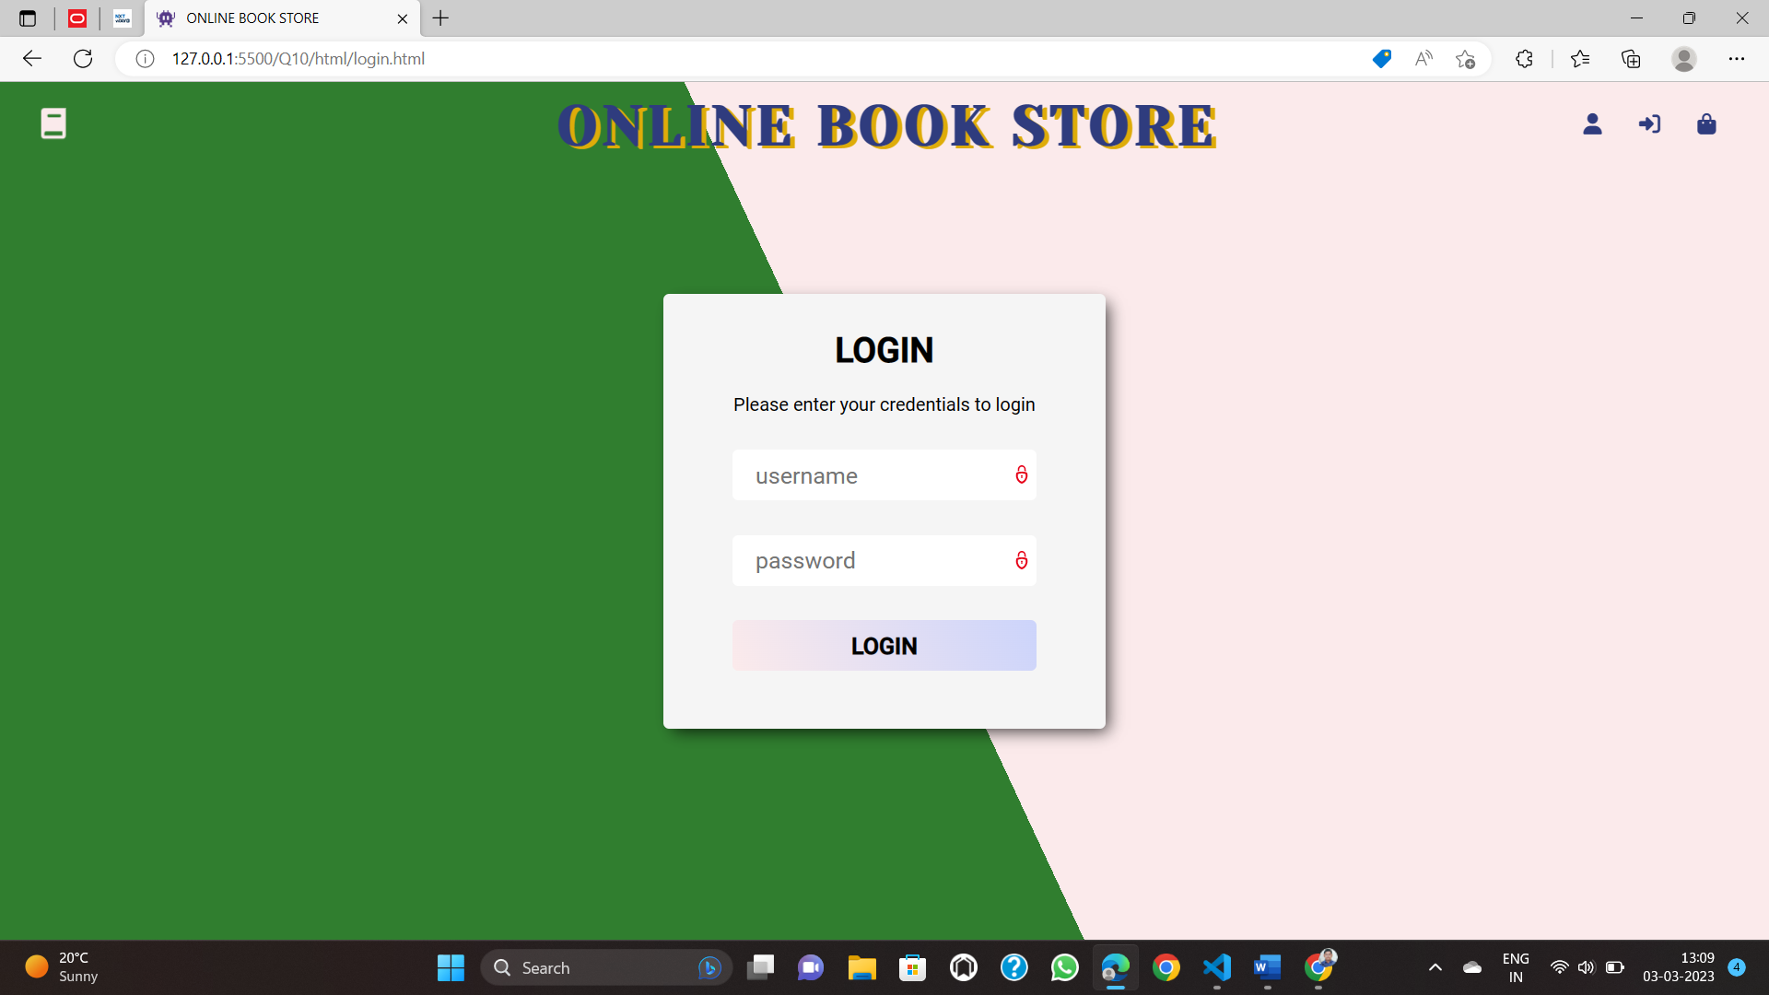

11. Write JavaScript to validate the following fields of the above registration page.

a. Name (Name should contains alphabets and the length should not be less than 6

Characters).

b. Password (Password should not be less than 6 characters length).

c. E-mail id (should not contain any invalid and must follow the standard pattern

name@domain.com)

d. Phone number (Phone number should contain 10 digits only).

CODE:

Form.html:

<!DOCTYPE *html*>

<html *lang*="en">

<head>

    <meta *charset*="UTF-8">

    <meta *http-equiv*="X-UA-Compatible" *content*="IE=edge">

    <meta *name*="viewport" *content*="width=device-width, initial-scale=1.0">

    <title>Registration</title>

    <link *rel*="stylesheet" *href*="Q2style.css">

</head>

<body>

  <script>

    function validate() {

      let full_name = document.querySelector("#name").value;

      let email = document.querySelector("#email").value;

      let phone = document.querySelector("#phone").value;

      let username = document.querySelector("#username").value;

      let password = document.querySelector("#password").value;

      const nameRegex = /^[a-zA-Z]+ [a-zA-Z]+$/;

      if (nameRegex.test(full_name) == false) alert("Invalid name");

      const emailRegex = /^[a-zA-Z0-9._%+-]+@[a-zA-Z0-9.-]+\.[a-zA-Z]{2,}$/;

      if (emailRegex.test(email) === false) alert("invalid email");

      const phoneRegex = /^[6-9]\d{9}$/;

      if (phoneRegex.test(phone) === false) alert("Invalid phone number");

      const usernameRegex = /^[a-zA-Z0-9]+([._]?[a-zA-Z0-9]+)*$/;

      if (usernameRegex.test(username) === false) alert("Invalid username");

      const passwordRegex = /^(?=.*[a-z])(?=.*[A-Z])(?=.*\d)[a-zA-Z\d]{8,}$/;

      if (passwordRegex.test(password) === false) alert("Invalid password");

      const checkboxes = document.querySelectorAll("input[type=checkbox]");

      const checkboxLength = checkboxes.length;

      function isChecked() {

        for (let i = 0; i < checkboxLength; i++) {

          if (checkboxes[i].checked) *return* true;

        }

*return* false;

      }

      if(isChecked() === false) alert('Please select atleast one language')

    }

  </script>

    <h1 align="center">Student Registration Form</h1>

    <form *action*="#">

        <fieldset>

            <legend>Basic Information</legend>

            <table>

                <tr>

                    <td>

                        <label *for*="fname">First Name*:</label>

                    </td>

                    <td>

                        <input *type*="text" *name*="fname" *id*="" *required*>

                        <span *class*="ml">

                            <label *for*="mname">Middle Name:</label>

                            <input *type*="text" *name*="mname" *id*="">

                        </span>

                        <span *class*="ml">

                            <label *for*="lname">Last Name*:</label>

                            <input *type*="text" *name*="lname" *id*="" *required*>

                        </span>

                    </td>

                </tr>

                <tr>

                    <td>

                        <label *for*="roll">Roll No*:</label>

                    </td>

                    <td><input *type*="text" *name*="roll" *id*="" *required*></td>

                </tr>

                <tr>

                    <td>

                        <label *for*="email">Email*:</label>

                    </td>

                    <td><input *type*="email" *name*="email" *id*="" *required*></td>

                </tr>

                <tr>

                    <td>

                        <label *for*="phone">Phone No*:</label>

                    </td>

                    <td><input *type*="number" *name*="phone" *id*="" *required*></td>

                </tr>

                <tr>

                    <td>

                        <label *for*="uid">User ID*:</label>

                    </td>

                    <td><input *type*="text" *name*="uid" *id*="" *required*></td>

                </tr>

                <tr>

                    <td>

                        <label *for*="pass">Password*:</label>

                    </td>

                    <td><input *type*="password" *name*="pass" *id*="" *required*></td>

                </tr>

                <tr>

                    <td>

                        <label *for*="rpass">Re-enter Password*:</label>

                    </td>

                    <td><input *type*="password" *name*="rpass" *id*="" *required*></td>

                </tr>

                <tr>

                    <td>

                        <label *for*="branch">Branch*:</label>

                    </td>

                    <td>

                        <select *name*="branch" *id*="">

                            <option *value*="CSE">CSE</option>

                            <option *value*="ECE">ECE</option>

                            <option *value*="EEE">EEE</option>

                            <option *value*="Mechanical">Mechanical</option>

                        </select>

                    </td>

                </tr>

                <tr>

                    <td>

                        <label *for*="yos">Year of Study*:</label>

                    </td>

                    <td>

                        <select *name*="yos" *id*="">

                            <option *value*="first">first</option>

                            <option *value*="second">second</option>

                            <option *value*="third">third</option>

                        </select>

                    </td>

                </tr>

                <tr>

                    <td><label *for*="photo">Upload Photo*:</label></td>

                    <td><input *type*="file" *name*="photo" *id*=""></td>

                </tr>

            </table>

        </fieldset>

        <fieldset>

            <legend>Personal Details</legend>

            <table>

                <tr>

                    <td><label *for*="father-name">Father's Name*:</label></td>

                    <td><input *type*="text" *name*="father-name" *id*="" *required*></td>

                    <td><label *for*="father-contact">Contact No*:</label></td>

                    <td><input *type*="text" *name*="father-contact" *id*="" *required*></td>

                </tr>

                <tr>

                    <td><label *for*="mother-name">Mother's Name*:</label></td>

                    <td><input *type*="text" *name*="mother-name" *id*="" *required*></td>

                    <td><label *for*="mother-contact">Contact No*:</label></td>

                    <td><input *type*="text" *name*="mother-contact" *id*="" *required*></td>

                </tr>

                <tr>

                    <td><label *for*="dob">Date of Birth*:</label></td>

                    <td><input *type*="date" *name*="dob" *id*="" *required*></td>

                </tr>

                <tr>

                    <td><label *for*="aadhar">Aadhar No*:</label></td>

                    <td><input *type*="text" *name*="aadhar" *id*="" *required*></td>

                </tr>

            </table>

        </fieldset>

        <fieldset>

            <legend>Address</legend>

            <table>

                <tr>

                    <td><label *for*="address1">Address 1*:</label></td>

                    <td><textarea *name*="address1" *id*="" *cols*="30" *rows*="10" *required*></textarea></td>

                </tr>

                <tr>

                    <td><label *for*="address2">Address 2*:</label></td>

                    <td><textarea *name*="address2" *id*="" *cols*="30" *rows*="10" *required*></textarea></td>

                </tr>

            </table>

        </fieldset>

        <div *class*="center">

            <button *value*="Register"> </button>

            <input *type*="button" *value*="Reset">

        </div>

    </form>

</body>

</html>

Registration.js:

function validate() {

*// Get the values from the input fields*

  const name = document.getElementById('name').value;

  const password = document.getElementById('password').value;

  const email = document.getElementById('email').value;

  const phoneNumber = document.getElementById('phone').value;

*// Regular expressions for validation*

  const nameRegex = /^[a-zA-Z]{6,}$/;

  const passwordRegex = /^.{6,}$/;

  const emailRegex = /^[^\s@]+@[^\s@]+\.[^\s@]+$/;

  const phoneNumberRegex = /^[0-9]{10}$/;

*// Validate the name field*

  if (!nameRegex.test(name)) {

    alert('Name should contain only alphabets and be at least 6 characters long.');

*return* false;

  }

*// Validate the password field*

  if (!passwordRegex.test(password)) {

    alert('Password should be at least 6 characters long.');

*return* false;

  }

*// Validate the email field*

  if (!emailRegex.test(email)) {

    alert('Please enter a valid email address.');

*return* false;

  }

*// Validate the phone number field*

  if (!phoneNumberRegex.test(phoneNumber)) {

    alert('Phone number should contain 10 digits only.');

*return* false;

  }

*// If all fields are valid, return true*

*return* true;

}

const address = document.getElementById('address').value;

const city = document.getElementById('city').value;

const state = document.getElementById('state').value;

const zip = document.getElementById('zip').value;

function validateRegistrationForm() {

*// Get the values from the input fields*

  const name = document.getElementById('name').value;

  const password = document.getElementById('password').value;

  const email = document.getElementById('email').value;

  const phoneNumber = document.getElementById('phone').value;

*// Regular expressions for validation*

  const nameRegex = /^[a-zA-Z]{6,}$/;

  const passwordRegex = /^.{6,}$/;

  const emailRegex = /^[^\s@]+@[^\s@]+\.[^\s@]+$/;

  const phoneNumberRegex = /^[0-9]{10}$/;

*// Validate the name field*

  if (!nameRegex.test(name)) {

    alert('Name should contain only alphabets and be at least 6 characters long.');

*return* false;

  }

*// Validate the password field*

  if (!passwordRegex.test(password)) {

    alert('Password should be at least 6 characters long.');

*return* false;

  }

*// Validate the email field*

  if (!emailRegex.test(email)) {

    alert('Please enter a valid email address.');

*return* false;

  }

*// Validate the phone number field*

  if (!phoneNumberRegex.test(phoneNumber)) {

    alert('Phone number should contain 10 digits only.');

*return* false;

  }

*// If all fields are valid, return true*

*return* true;

}

12. You will create several files related to a recipe web site for a fictional pie company named

Granny's Pies. You need to turn in the following files:

• index.html, the first of two web pages (with an optional CSS style sheet file)

• pie.html, the second of two web pages

• recipe.css, the style sheet for pie.html

The first part of your task is to create a front page (README) for this web site, stored in a file

named index.html. Your front page must contain a link to pie.html. The file must also be at least 20

lines long and must contain at least 4 different XHTML elements in its body. It also may not

significantly borrow content from your pie.html. Otherwise, this front page can have any

appearance you like. If you like, you may use an optional CSS style sheet with this page

named index.css and submit it with your other files.

The second (and more substantial) part of the assignment is to recreate a specific web page

describing a recipe for lemon meringue pie, stored in a file named pie.html. Unlike index.html, this

page is rigidly specified and must exactly match the appearance specified in this document.

For full credit, your files must be uploaded to our web server and must match several stylistic

guidelines, all specified in the following sections.

CODE:

Index.html:

<!DOCTYPE *html*>

<html *lang*="en">

<head>

    <meta *charset*="UTF-8">

    <meta *http-equiv*="X-UA-Compatible" *content*="IE=edge">

    <meta *name*="viewport" *content*="width=device-width, initial-scale=1.0">

    <title>Q.12</title>

    <style>

        * {

            margin: 0;

*/* padding: 0; */*

        }

        body {

            background-color: rgb(215, 229, 250);

            font-family: 'Gill Sans', 'Gill Sans MT', Calibri, 'Trebuchet MS', sans-serif;

            margin: 0;

            padding: 20px 40px;

            font-size: 20px;

        }

        h1 {

            color: green;

            margin: 0 0 20px 0;

            font-size: 40px;

        }

        .desc {

            text-align: center;

            margin-bottom: 40px;

        }

        .desc p {

            font-size: 20px;

        }

        h3{

            font-size: 30px;

        }

    </style>

</head>

<body>

    <div *class*="desc">

        <h1>STRAWBERRY CAKES</h1>

        <p>Strawberry-scented cake is simply irresistible slathered with your favorite frosting

            or layered in whipped cream and strawberries.</p>

    </div>

    <h3>Nutrition Facts</h3>

    <p><b>Amount Per</b> 100 grams</p>

    <p><b>Calories</b> 371</p>

    <p>% Daily Value*</p>

    <ul>

        <li><b>Total Fat 15 g</b> 23%</li>

        <li><b>Saturated fat 5 g</b> 25%

        </li>

        <li><b>Polyunsaturated fat 2.8 g</b> </li>

        <li><b>Monounsaturated fat </b>6 g </li>

        <li><b>Cholesterol 58 mg</b> 19%</li>

        <li><b>Sodium 315 mg </b>13%</li>

        <li><b>Potassium 140 mg</b> 4%</li>

        <li><b>Total Carbohydrate 53 g</b> 17%</li>

        <li><b>Dietary fiber 1.6 g</b> 6%</li>

        <li><b>Protein 5 g</b> 10%</li>

        <li><b>Vitamin A</b> 2%</li>

        <li><b>Vitamin C</b> 0%</li>

        <li><b>Calcium</b> 6% </li>

        <li><b>Iron</b> 8%</li>

        <li><b>Vitamin D</b> 0% </li>

        <l><b>Vitamin B-6</b> 0%</li>

            <li><b>Vitamin B-12</b> 3% </li>

            <li><b>Magnesium</b> 8%</li>

    </ul>

    <div>*Per cent Daily Values are based on a 2,000 calorie diet. Your daily

        values may be higher or lower depending on your calorie needs.</div>

    <p>

        <a *href*="pie.html"> Click here for the recipe </a>

    </p>

</body>

</html>

Pie.html:

<html>

<head>

    <title>CAKE</title>

    <link *href*="recipe.css" *rel*="stylesheet" *type*="text/css">

    <style>

        * {

            margin: 0;

*/* padding: 0; */*

        }

        *::-webkit-scrollbar {

            display: none;

        }

        body {

            background-color: rgb(242, 250, 215);

            font-family: 'Gill Sans', 'Gill Sans MT', Calibri, 'Trebuchet MS', sans-serif;

            margin: 0;

            padding: 20px 40px;

            font-size: 20px;

        }

        h1 {

            text-align: center;

            color: green;

            margin: 0 0 20px 0;

            font-size: 40px;

        }

        #d {

            margin: auto;

            width: 50%;

            display: flex;

            justify-content: space-around;

        }

        hr {

            margin-top: 20px;

        }

        h2 {

            background-color: beige;

            padding: 20px;

            margin-bottom: 20px;

        }

        .comment{

            background-color: aliceblue;

            width: 80%;

            margin: 20px 20px;

            padding: 15px;

            border-radius: 10px;

        }

    </style>

</head>

<body>

    <h1>STRAWBERRY CAKE</h1>

    <div *id*="d">

        <img *src*="chef.webp" *height*="250" />

        <img *src*="s.webp" *height*="250px" />

    </div>

    <p><b>Preparation Time : </b>16-20 minutes</p>

    <p><b>Cooking time :</b> 21-25 minutes</p>

    <p><b>Servings :</b> 4</p>

    <hr />

    <h2>INGREDIENTS</h2>

    <ul>

        <li>1 1/2 cup(s) sifted cake flour</li>

        <li>1 1/2 teaspoon(s) baking powder</li>

        <li>1/4 teaspoon(s) salt</li>

        <li>1/2 cup(s) (1 stick) unsalted butter, softeneds</li>

        <li>1 cup(s) sugar</li>

        <li>2 large eggs, room temperature</li>

        <li>1/2 teaspoon(s) vanilla extract</li>

        <li>Milk 3/4 cup</li>

        <li>1/2 cup(s) whole milk </li>

    </ul>

    <hr />

    <h2>DIRECTIONS</h2>

    <ol *type*="1">

        <li>

            <h3>Step 1:</h3>

            <ul *type*="circle">

                <li>Grate strawberry.</li>

                <li>Cut the butter into cubes.</li>

                <li> Grease a Microwave proof dish.</li>

                <li>Melt butter and strawberry in a Microwave proof bowl in the Microwave

                    oven for one minute on Microwave HIGH (100%).</li>

            </ul>

        </li>

        <li>

            <h3>Step 2:</h3>

            <ul *type*="circle">

                <li>In another bowl sieve refined flour and baking powder.</li>

                <li> Mix the melted butter and strawberry well.</li>

            </ul>

        </li>

        <li>

            <h3>Step 3:</h3>

            <ul *type*="circle">

                <li>Add powdered sugar, strawberry essence and mix.</li>

                <li> Add the flour mixture and mix. </li>

                <li>Correct the consistency by adding milk.</li>

                <li>Add walnuts and mix gently.</li>

            </ul>

        </li>

        <li>

            <h3>Step 4:</h3>

            <ul *type*="circle">

                <li>Transfer the mixture into the greased Microwave proof dish. </li>

                <li>Bake in the Microwave at HIGH (100%) for seven minutes.</li>

            </ul>

        </li>

        <li>

            <h3>Step 5:</h3>

            <ul *type*="circle">

                <li>Allow standing time of five minutes.</li>

                <li> Cool, slice and serve.</li>

            </ul>

        </li>

    </ol>

    <hr />

    <h2><u>USER COMMENTS</u></h2>

    <div *class*="comments">

        <div *class*="comment">

            <i>This is a very good recipe to follow as it is sweet and simple.

                This delicious cake can be enjoyed by the vegeterians too.</i>

            <p><b>-Sujata Kumari </b></p>

        </div>

        <div *class*="comment">

            <i>Strawberry cake is the very best. I love Strawberries :) </i>

            <p><b>-Nandi</b></p>

        </div>

    </div>

    <h2>LINKS</h2>

    <p><a *href*="index.html">Home</a></p>

</body>

</html>





13. Build a Calculator using HTML form elements and JavaScript.

CODE:

Index.html:

<!DOCTYPE *html*>

<html *lang*="en">

<head>

  <meta *charset*="UTF-8">

  <meta *http-equiv*="X-UA-Compatible" *content*="IE=edge">

  <meta *name*="viewport" *content*="width=device-width, initial-scale=1.0">

  <title>🧮</title>

  <link *rel*="stylesheet" *href*="style.css">

</head>

<body>

  <h1 *style*="margin-top: 0;">CALCULATOR</h1>

  <div *class*="container">

    <div *id*="display">0</div>

    <div *class*="buttons">

      <div *class*="button">1</div>

      <div *class*="button">2</div>

      <div *class*="button">3</div>

      <div *class*="button">C</div>

      <div *class*="button">4</div>

      <div *class*="button">5</div>

      <div *class*="button">6</div>

      <div *class*="button">-</div>

      <div *class*="button">7</div>

      <div *class*="button">8</div>

      <div *class*="button">9</div>

      <div *class*="button">&times;</div>

      <div *class*="button equals">=</div>

      <div *class*="button">0</div>

      <div *class*="button">+</div>

    </div>

  </div>

  <script *src*="index.js"></script>

</body>

</html>

Index.js:

let display = document.getElementById("display");

let buttons = Array.from(document.getElementsByClassName("button"));

buttons.map((button) => {

  button.addEventListener("click", (e) => {

    switch (e.target.innerText) {

      case "C":

        display.innerText = "0";

        break;

      case "=":

        try {

          display.innerText = eval(display.innerText);

        } catch {

          display.innerText = "Error";

        }

        break;

      case "←":

        if (display.innerText) {

          display.innerText = display.innerText.slice(0, -1);

        }

        break;

      default:

        console.log(e.target.innerText);

        if (display.innerText == "0") display.innerText = e.target.innerText;

        else {

          if (e.target.innerText == "×") display.innerText += "*";

          else display.innerText += e.target.innerText;

        }

    }

  });

});

Style.css:

body {

  font-size: 2rem;

  margin: 0;

  padding: 0;

  height: 100vh;

  display: flex;

  justify-content: center;

  align-items: center;

  font-family: 'consolas';

  flex-direction: column;

  background: rgb(238, 174, 202);

  background: radial-gradient(circle, rgba(238, 174, 202, 1) 0%, rgba(148, 187, 233, 1) 100%);

}

#display {

  background-color: #323232;

  width: 300px;

  color: #FFF2F9;

  margin: 10px;

  padding: 20px;

  text-align: right;

  border-radius: 10px;

  user-select: all;

}

#display::selection {

  color: white;

  background-color: blueviolet;

}

.container {

  background-color: #FE83C6;

  padding: 20px;

  border-radius: 20px;

}

.buttons {

  user-select: none;

  padding: 20px 20px 10px 20px;

*/* width: 300px; */*

  display: grid;

  grid-template-columns: auto auto auto auto;

*/* background-color: pink; */*

  grid-gap: 8px;

}

.button {

*/* border: 1px solid; */*

  background-color: #FFF2F9;

  color: #323232;

  padding: 5px;

  text-align: center;

  padding: 18px 5px;

  border-radius: 50%;

  margin-bottom: 10px;

}

.equals {

  grid-column-start: 1;

  grid-column-end: 3;

  border-radius: 20px;

  margin-bottom: 10px;

}

.button:hover {

  background-color: #323232;

  color: #FFF2F9;

  transition: 150ms ease-out;

}



14. Write a script that calculates the squares and cubes of the numbers from 0 to 10 and

outputs

XHTML text that displays the resulting values in an XHTML table format, as follows:

Number square cube

0 0 0

1 1 1

2 4 8

3 9 27

4 16 64

5 25 125

6 36 216

7 49 343

CODE:

<!DOCTYPE *html*>

<html>

<head>

  <title>Squares and Cubes Table</title>

</head>

<body>

  <table>

    <tr>

      <th>Number</th>

      <th>Square</th>

      <th>Cube</th>

    </tr>

    <script>

      for (var i = 0; i <= 10; i++) {

        var square = i * i;

        var cube = i * i * i;

        document.write("<tr>");

        document.write("<td>" + i + "</td>");

        document.write("<td>" + square + "</td>");

        document.write("<td>" + cube + "</td>");

        document.write("</tr>");

      }

    </script>

  </table>

</body>

</html>



15. Develop a JavaScript program that will determine the gross pay for each of three

employees.

The company pays “straight time” for the first 40 hours worked by each employee and

pays “time and a half” for all hours worked in excess of 40 hours. You are given a list of

the employees of the company, the number of hours each employee worked last week and

the hourly rate of each employee. Your program should input this information for each

employee, determine the employee’s gross pay and output XHTML text that displays the

employee's gross pay. Use prompt dialogs to input the data.

CODE:

<!DOCTYPE *html*>

<html *lang*="en">

<head>

    <meta *charset*="UTF-8">

    <meta *http-equiv*="X-UA-Compatible" *content*="IE=edge">

    <meta *name*="viewport" *content*="width=device-width, initial-scale=1.0">

    <title>Employee Payment Calculator</title>

    <script *src*="index.js"></script>

    <style>

        *{

            padding: 0;

            margin: 0;

            box-sizing: border-box;

        }

        body{

            font-family: 'Courier New', Courier, monospace;

        }

        button{

            cursor: pointer;

            font-family: 'Courier New', Courier, monospace;

            background: none;

            border: 2px solid black;

            border-radius: 5px;

            font-weight: bold;

            font-size: 20px;

            padding: 10px;

            display: block;

            margin: 30px auto;

            transition: all .2s;

        }

        button:hover{

            background-color: rgb(42, 42, 42);

            color: whitesmoke

        }

        #results{

            width: 80%;

            margin: auto;

            background-color: beige;

            padding: 20px;

            font-weight: bold;

            font-size: 25px;

            border-radius: 5px;

        }

        #results p{

            margin: 10px

        }

    </style>

</head>

<body>

    <button *onclick*="calculate()">Enter New Employee</button>

    <div *id*="results"></div>

</body>

</html>

Index.js:

let employees = []

function grossPay(employee){

    if(employee.hours <= 40) *return* employee.hours * employee.rate

*return* 40 * employee.rate + (employee.hours - 40) * employee.rate * 1.5

}

function calculate(){

    let name = prompt('Enter name of Employee')

    let hours = parseInt(prompt('Enter hours worked by employee'))

    let rate = parseFloat(prompt('Enter the hourly rate of employee'))

    employee = {

        name: name,

        hours: hours,

        rate: rate

    }

    employees.push(employee)

    display_details()

}

function display_details(){

    let newEmpIndex = employees.length - 1;

    let newEmpPaymentDetails = `<p>${employees[newEmpIndex].name} is paid &#8377;${grossPay(employees[newEmpIndex])} for working ${employees[newEmpIndex].hours} hours</p>`

    document.querySelector('#results').innerHTML += newEmpPaymentDetails;

}



16. Write a script that reads several lines of text and prints a table indicating the number of

Occurrences of each different word in the text. The first version of your program should

include the words in the table in the same order in which they appear in the text.

CODE:

Index.html:

<!DOCTYPE *html*>

<html *lang*="en">

  <head>

    <meta *charset*="UTF-8" />

    <meta *http-equiv*="X-UA-Compatible" *content*="IE=edge" />

    <meta *name*="viewport" *content*="width=device-width, initial-scale=1.0" />

    <title>Document</title>

  </head>

  <body>

    <div *class*="text"></div>

    <table>

      <thead>

        <th>Word</th>

        <th>Word length</th>

        <th>No. of occurences</th>

      </thead>

      <tbody></tbody>

    </table>

    <script *src*="index.js"></script>

  </body>

</html>

Index.js:

(tbody = document.getElementsByTagName("tbody")[0]),

  (dataDiv = document.getElementsByClassName("text")[0]);

var data = prompt("Enter some lines:");

dataDiv.textContent = `You entered: ${data}`;

const arr = data.split(" ");

var dict = [];

arr.forEach((element) => {

  if (element != "") {

    x = dict.find((o) => o[0] == element);

    if (x) {

      x[1] += 1;

    } else {

      var arr2 = [element, 1];

      dict.push(arr2);

    }

  }

});

dict.forEach((row) => {

  tr = document.createElement("tr");

  td1 = document.createElement("td");

  td1.textContent = row[0];

  td2 = document.createElement("td");

  td2.textContent = row[0].length;

  td3 = document.createElement("td3");

  td3.textContent = row[1];

  tr.appendChild(td1);

  tr.appendChild(td2);

  tr.appendChild(td3);

  tbody.appendChild(tr);

});



17. Once an HTML page completes loading it greets a user with a message ‘Welcome’. When a

user leaves this page, the ‘Good-bye’ alert box is displayed.

<!DOCTYPE *html*>

<html *lang*="en">

*<!--*

*PLEASE INTERACT WITH THE WEBSITE FIRST IN ORDER TO FIRE THE BEFOREUNLOAD EVENT*

*-->*

<head>

    <meta *charset*="UTF-8">

    <meta *http-equiv*="X-UA-Compatible" *content*="IE=edge">

    <meta *name*="viewport" *content*="width=device-width, initial-scale=1.0">

    <title>Document</title>

    <style>

        * {

            margin: 0;

            padding: 0;

            font-family: 'Courier New', Courier, monospace;

        }

        body {

            height: 100vh;

            display: flex;

            align-items: center;

            justify-content: center;

            font-size: 30px;

            background-color: beige;

            color: brown;

        }

    </style>

</head>

<body>

    <h1>Click on me before exiting the webpage</h1>

    <script *defer*>

        window.onload = alert('Welcome');

        document.body.addEventListener('click', () => {

            let h1 = document.getElementsByTagName('h1')[0];

            h1.innerHTML = 'You can exit this page :)'

        })

        window.addEventListener("beforeunload", function (event) {

            event.preventDefault();

            event.returnValue = "Bye Bye"; *// you cannot show personalized messages to the user*

        });

    </script>

</body>

</html>

 



18. Write a Javascript code block, which validates a username and password against hard

coded values.

If either the name or password field is not entered, display an error message showing:

“You forget one of the required fields. Please try again.”

In case, the fields entered do not match the hard coded values, display an error message

showing:

“Please enter a valid username or password”

If the fields entered match, display the following message:”Welcome (username)”.

CODE:

Index.html:

<!DOCTYPE *html*>

<html *lang*="en">

<head>

    <meta *charset*="UTF-8">

    <meta *http-equiv*="X-UA-Compatible" *content*="IE=edge">

    <meta *name*="viewport" *content*="width=device-width, initial-scale=1.0">

    <title>Login</title>

    <style>

        *{

            margin: 0;

            padding: 0;

            box-sizing: border-box;

            font-family: 'Gill Sans', 'Gill Sans MT', Calibri, 'Trebuchet MS', sans-serif;

        }

        body{

            height: 100vh;

            display: flex;

            justify-content: center;

            align-items: center;

        }

        .page-content{

            border-radius: 10px;

            width: 50%;

            background-color: blanchedalmond;

            margin: auto;

            height: 50vh;

            display: flex;

            justify-content: center;

            align-items: center;

            border: 1px solid ;

            box-shadow: 8px 8px 0 0 rgb(153, 153, 140)

        }

        .login{

            font-size: 30px;

            display: grid;

*/* display: none; */*

            grid-template-columns: 1fr 2fr;

            grid-gap: 10px;

        }

        .result{

            display: none;

            font-size: 30px;

        }

        input[type='text'], input[type='password']{

            padding: 10px;

        }

        input[type='submit']{

            margin-top: 20px;

            padding: 10px;

            background: none;

            border: 1px solid rgb(168, 137, 137);

        }

    </style>

    <script *src*="index.js" *defer*></script>

</head>

<body>

    <div *class*="page-content">

            <form *action*="#" *class*="login" *onsubmit*="login(); *return* false;">

                <label *for*="username">Username:</label>

                <input *type*="text" *name*="username" *id*="username">

                <label *for*="password">Password:</label>

                <input *type*="password" *name*="password" *id*="password">

                <input *type*="submit" *value*="Login">

            </form>

        <div *class*="result"></div>

    </div>

    <div *class*="result"></div>

</body>

</html>

Index.js:

const uname = 'xarcode'

const pass = '12345'

let login = () => {

    let username = document.querySelector('#username').value;

    let password = document.querySelector('#password').value;

    if(username.length == 0) alert('Please input username')

    if(password.length == 0) alert('Please input password')

    if(username != uname || password != pass)

        alert('Username or password does not match')

    else{

        let loginForm = document.querySelector('.login');

        loginForm.style.display = 'none';

        let result = document.querySelector('.result');

        result.style.display = 'block'

        result.innerHTML = `WELCOME ${username}`;

    }

    }



END